Transplant Support for Professionals

Department of Paediatric Cardiothoracic Transplantation

INTRODUCTION

Many thanks for being involved in the shared care, prescription of medicines and long term follow up of these children following heart or lung transplantation. Solid organ transplantation is rare in children and we hope that this booklet will provide you with support and the answers to common questions you may encounter during your care of these children.

There may be rare occasions when you need further advice and we can be contacted 24 hours a day.

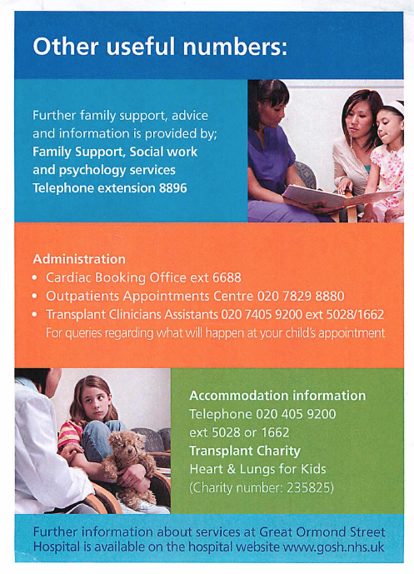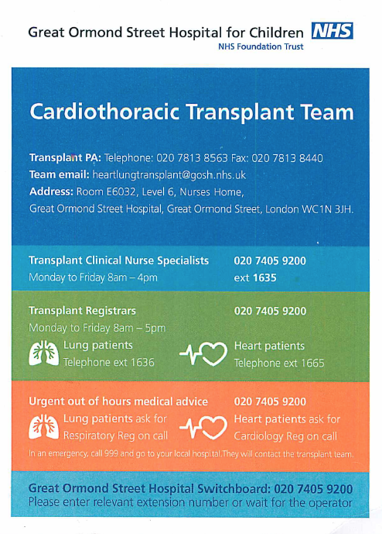

PAEDIATRIC HEART AND LUNG TRANSPLANTATION AT GOSH

Heart and Lung transplantation started at GOSH in 1988 and since then more than 500 patients have received an organ. Nearly all of the children have an excellent quality of life, attending school and taking part in physical activities on a regular basis.

Heart or Lung transplantation is a life limiting condition and we need help to make sure that children and their families have the best support we can offer. Prognosis and quality of life depend on us making sure that appropriate medication is available and monitored to ensure that they do not experience rejection and that we limit the side effects related to immunosuppression.

SHARED CARE AFTER LUNG OR HEART-LUNG TRANSPLANT

Shared care with local paediatricians and respiratory physicians

For the first 1 year after transplant children are seen on a regular basis in clinic here at GOSH. Many children will be discharged within three weeks after the transplant procedure and regular clinic review is required to ensure that they remain well. It is within the first 1 year after transplant that complications are most likely to happen.

After 1 year, clinic visits are less frequent (3monthly) and it becomes more likely that local teams will be involved. The purpose of scheduled visits is to ensure that we detect any problems early, particularly related to ensuring adequate immunosuppression and detecting potential complications of treatment, including rejection, infection, renal dysfunction, hypertension, diabetes mellitius and the rare occurrence of post transplant lymphoproliferative disease (PTLD). Side effects to medication are also important and these most frequently include low white cell count and diarrhoea. Signs of a high tacrolimus level can include hypersensitivity of hands and feet and headache.

What to do during a visit

History

Asking about exercise ability, general malaise and mild fever is important as rejection can be very non-specific. Some children will have recurrent infections. It is important to enquire about symptoms of cough and shortness of breath. Routine paediatric problems such as warts and veruccas are common and specific advice or referral may be required. Families will have a written record of their medication doses in their drug diary and this should be updated with any changes in medication that may have occurred since the last visit. Patients are sent home with a hand held spirometer and should record their lung function on a daily basis. They are asked to contact the transplant office if there is a 10% drop in their lung function values. Poor compliance with medication is the most common reason for rejection episodes and we would be happy to help with any concerns professionals may have.

Examination

Measuring temperature, oxygen saturation and blood pressure is important. A full respiratory examination should be completed and we would expect a child’s chest to sound clear. Examination for evidence of hepatosplenomegaly and lymphadenopathy is important as it may be a sign of PTLD. After lung transplant some children will require anti-hypertensives. After heart-lung transplant the heart rate may either be faster than expected due to the lack of vagal nerve activity and can be low if a rhythm abnormality is present. A gallop rhythm is an ominous sign in heart-lung transplant recipients and should prompt urgent referral for further assessment.

Investigations
- CXR
- Lung Function – spirometry should be measured at each visit if available
- Blood tests – Levels of immunosuppression are checked every six weeks as the longest interval and more frequently early after transplant. Levels should be taken as a trough meaning that morning doses of medicine should not be given before blood has been drawn during the clinic visit. On occasion this might mean delaying the dose the previous night to ensure that a 12 hour level Tacrolimus or 24 hour level (Sirolimus) is possible. These samples require 0.5 mls in an EDTA tube (FBC tube) and can be sent to us here at GOSH for analysis. Please record the dose, time taken and time from previous dose on the form. Please ensure that blood samples are packaged appropriately to avoid spillage in the post. Other blood tests e.g. FBC, U&E, LFT, glucose and bone profile can be analysed locally.
- Bronchoscopy and transbronchial biopsy – Routine surveillance bronchoscopy is carried out at 1 week, 1 month, 3 months, 6 months and 1 year post transplant. In addition if there are any clinical concerns about rejection or infection bronchoscopy will normally be arranged at GOSH.
- Echocardiography is used to monitor heart-lung graft function. Particular attention should be paid to left ventricular function with diastolic and systolic measurements. Poor function, significant wall thickening, a pericardial effusion and development of new mitral regurgitation might indicate that rejection is present.
- ECG is used to detect any significant conduction problems since the last visit. Any major changes in amplitude may indicate rejection. Some of the medications used may prolong QT interval and a baseline ECG will be completed for all patients prior to discharge.

Cardiothoracic Transplant Unit
Level 6 Main Nurses Home
Great Ormond Street Hospital for Children
London WC1N 3JH

We would be grateful if you could let us know if blood tests are taken of children present unwell so that we check results and respond appropriately.

Shared care with General Practitioners

Children may present to their general practitioners with the usual childhood ailments. Some childhood illnesses require different treatment after a heart or lung transplant, for instance when a child has a contact with or develops chickenpox. A few common scenarios and appropriate responses are discussed later in this document. Expert local care can help to identify rejection episodes early and detect complications for which your patients might need more support from us.

The transplant patients we look after come from all over the country and it is an enormous help to them if they are able to get their medication from their local surgery. Patients tell us that not being able to source vital medicines locally causes significant anxiety, particularly when they are running low. Drugs used to prevent rejection after transplant and to prevent complications are not often familiar, particularly when prescribed in children. We have outlined below the responsibilities of the shared care participants in order to support this process.

Transplant unit responsibilities

- To initiate, monitor and titrate doses of medication
- To arrange testing at appropriate intervals and review all levels to ensure optimal immunosuppression and interpretation of abnormal results
- Communicate changes in dose in writing to the GP
- Communicate with families the results of tests and advise of any changes in medication doses.

GP Responsibilities

- Prescribe medication according to dose advised by the transplant unit
- Monitor for compliance and liaise with the transplant unit regarding any circumstances that might indicate poor compliance
- Arrange appropriate local referral for co-morbidities post transplant
- Arrange yearly flu vaccine
- Avoid the administration of live vaccines e.g. MMR, Varicella, yellow fever, BCG, oral typhoid or polio

Patient and Family responsibilities

- Compliance with medication and dietary advice
- To attend reviews
- To communicate with the transplant specialist nurses when they or their child are unwell or blood tests have been sent for analysis
- To maintain a record of current medications and bring it to appointments

Common Questions after Heart or Lung transplant

What immunisations can my child have after a transplant?

Children should be encourages to have all the recommended vaccines unless they are live. The table below gives the dos and don’ts of vaccinations

Permitted vaccines | Prohibited vaccines
Inactivated polio to family members | Live polio to family members
Influenza | MMR combined or separate
Hepatitis A and B | BCG
Cholera | Smallpox
Meningococcal A and C | Oral typhoid
Typhoid | Varicella
Haemophilus Influenza B | Yellow fever
DTP vaccine
Conjugated and polysaccharide Pneumococcal vaccine
HPV (human papilloma virus)

What should I do if my child comes into contact with chicken pox?

Many children have had chicken pox before transplant and afterwards immunity is preserved. We will let the family know immune status at discharge from hospital after transplant. For patients who are non immune immunoglobulin is available to prevent chicken pox after a contact. This usually is most effective within 72 hours but can be given up to 10 days after contact.

In the event of a significant contact aciclovir should be started 7 days after contact and continued for a further 7 days at prophylactic dose. Extra care should be taken for patients who are receiving steroids and these patients should have both VZV immunoglobulin and aciclovir prophylaxis.

If active chickenpox develops following this then aciclovir at treatment dose should be prescribed for 10 to 14 days.

What should I do if my child comes into contact with measles?

The decision to give immunoglobulin is based on the degree of exposure and degree of immunosuppression. Please contact the transplant team for further advice.

My child has vomited their medicines. What should I do?

If the child has vomited within 30 minutes of the dose then give a repeat dose. If longer than this there is no need repeat as it is likely that the drugs will have been absorbed adequately.

How do I know the results of my blood tests?

Part of the transplant office daily routine is to check blood test results and communicate with the family. The clinical nurse specialists will contact the family and advice of any dose adjustments.

What do I do if a dose of medication has been missed?

The first thing to do is to take the dose of medication that has been omitted. Make a note of it in your drug diary. Do not carry on with the subsequent dose as planned if it’s due within the next 8 hours. Contact the transplant team if you need further advice.

My child has diarrhoea and vomiting?

Short episodes of D&V should not have any significant effect on drug levels. If the illness is prolonged this may lead to either low or high drug levels which may need closer monitoring. Contact the transplant team if the illness goes on for longer than 24 hours. Patients may be at risk of dehydration and renal impairment and rehydration therapy should be commenced.

Should physical activity be restricted?

No. Physical activity should be encouraged once over the transplant operation, but for the first 3 months we don’t advise any exercise that causes shearing forces across the chest (e.g. rowing) and we suggest that swimming should be avoided for the first 3 months.

When can my child return to school?

We usually recommend that children return to school three months after the transplant operation. This is because their immune system is at its weakest during this period.

Can I go to crowded places immediately after the transplant?

We would recommend that places with lots of people, including public transport be avoided for the first three months. This is not always practical of course. We would also advise that avoiding others with obvious infections is sensible for the at least the first three months.

Are there any medicines I shouldn’t take?

There are a number of medicines that can interact with tacrolimus. Before any new medicines are started they should be checked with the transplant office. Patients should not have any Non-steroidal anti-inflammatory medicines because of the affect on the kidney.

Are there any foods which I shouldn’t eat?

The most important dietary advice is to make sure that food is cooked appropriately. Fruit and vegetables should be washed prior to preparation. Some foods can contain bacteria and should be avoided.

The following are safe foods:

Pasteurised milk and yoghurts
Well-cooked omelettes, and boiled or scrambled eggs
Pasteurised cheese such as cheddar and edam, processed cheese such as Philadelphia, Dairylea and cottage cheese
Cooked meat, bottled meat pastes or tinned meat

The following are foods to avoid:

Grapefruit or grapefruit juice (can interfere with tacrolimus level)
Unpasteurised milk, and yoghurts made from unpasteurised milk
Foods made with raw/undercooked eggs such as home-made mayonnaise and tiramisu
Cheese made from unpasteurised milk such as parmesan, mascarpone, feta, stilton, brie and camembert
Raw or undercooked meat such as paté or rare-cooked steak

If you have any questions that are not answered within this document then please contact the cardiothoracic transplant office on the contact number at the top of the page.

