Great Ormond Street Hospital Biomedical Research Centre
Joint Research and Development Office
UCL Great Ormond Street Institute of Child Health
30 Guilford Street
London WC1N1EH

Tel: 020 7905 2844
Email: BRC@gosh.nhs.uk
Web: www.gosh.nhs.uk/brc
GOSH BRC Novel Therapies Project Adoption Call
Deadline for Q1 2018 applications March 2nd 5pm
Send your completed applications to Dauda Bappa (dauda.bappa@gosh.nhs.uk)

Novel Therapies are opening a regular call for project adoption based on its core resources & infrastructure. It will hold 4 calls and reviews per year with the first in 2018 now open and all 2018 Q1 applications will be reviewed before the end of March 2018. Applications will be internally shortlisted by Novel Therapies then presented to the Science Board for review and ratification. Specific areas of clinical research supported by the Theme core infrastructure are the following:
- Study coordinators
- Health Care Assistants (for collecting biosamples)
- Mass spectrometry (pilot studies)
- Magnetic Resonance Imaging (pilot studies)
- Some limited funds will be made available for e.g. Mass spec and MRI
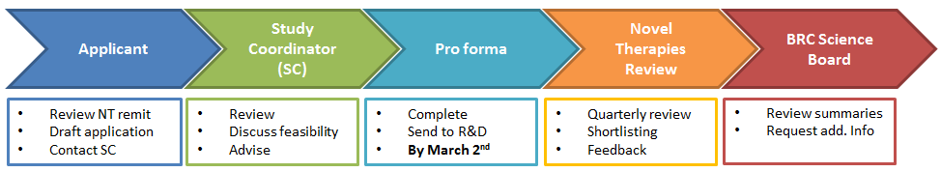
Applicants should complete their applications on the attached proforma. The call is open to all active researchers within GOSH and ICH. We encourage applicants to combine this application with other funding calls; Rare Diseases 2018 call opens January 5th 2018, with a deadline of February 16th and the applications will be also reviewed in late March. Please check the GOSH BRC website for more details or contact Dauda Bappa (dauda.bappa@gosh.nhs.uk).

Important Dates
- 5th January - application process opens for Q1 2018
- 16th February - Rare Diseases funding call deadline (if applying in conjunction)
- 2nd 5pm March - Project Adoption Q1 application deadline
- Late March - Novel Therapies shortlisting and review
- April - applicants informed of decision

No animal research is supported. For any queries please contact Dauda Bappa - dauda.bappa@gosh.nhs.uk. For study coordinator help, please contact Wendy Heywood - wendy.heywood@ucl.ac.uk.
Proforma

Key information
Project Title
Requested resource (e.g. Study Coordinator, MRI)
Title and Name
Email
Department
Which GOSH BRC theme does your research apply to:
R&D Number (if known)
Expected Start Date
Expected End Date
Proposed Research Project
Background, rationale, resources required with justification
Deliverables
Key objectives and deliverables, research plans
Joint Funding Call Details (if applicable)
If you are combining this application with another funding call, synergy between this and other funding call

Staff Required
For Study Coordinators of Health Care Assistants requests
Name/Position (if known) | Employee  type | Start date  on project | End date  on project | %FTE, hr/wk  or PAs/wk

Non-staff costs
Some limited funds will be available e.g. for use with the Mass spec or MRI
Item/consumable | Start date  on project | End date  on project | Cost £

