NIHR GOSH BRC Translational Research (Non-Clinical) PhD Studentships
PhD Project Portfolio
Application deadline Wednesday 15 May 2024

BRC Theme: Accelerating Novel Therapies

Project A1
Project title: Developing an ADAR-mediated RNA editing therapy for treatment of Duchenne Muscular Dystrophy
Supervisory Team:
Dr Haiyan Zhou, UCL Great Ormond Street Institute of Child Health (primary)
Dr Jinhong Meng, UCL Great Ormond Street Institute of Child Health (subsidiary)
Professor Francesco Muntoni, UCL Great Ormond Street Institute of Child Health (subsidiary)

Contact: Haiyan Zhou - Haiyan.zhou@ucl.ac.uk and Jinhong Meng - Jinhong.meng@ucl.ac.uk
Background:
Duchenne muscular dystrophy (DMD) is a severe X-linked genetic disorder affecting 1:5000 boys at birth (1). DMD is caused by mutations in Dystrophin gene, with around 10% of the cases caused by nonsense mutations (2,3). This type of mutations could be corrected by base editing which elicits A-to-I or C-to-T changes to restore the reading frame of the DMD transcripts.

Mini-dCas13X–mediated RNA adenine base editing (mxABE) has recently been reported to effectively correct the DMD nonsense mutations. This was achieved by AAV vectors expressing the exogenous ADAR enzyme (4). The editing efficiency was high both in vitro and in vivo, but concerns remain that ectopic expression of ADAR may cause unintended immunogenicity from the body. Alternatively, RESTORE (Recruiting Endogenous ADAR to Specific Transcripts for Oligonucleotide-mediated RNA Editing) is an antisense oligonucleotides (AONs) based approach utilizing chemically modified gRNA that recruit endogenous ADARs to edit transcripts in a simple and programmable way, making it an attractive approach in correcting the DMD nonsense mutations.

To evaluate the efficiency of the DMD mutation, a robust cellular system closely mimicking the muscle environment is required. DMD iPSCs derived myo-progenitor cells have profound proliferation and differentiation capacity, providing an excellent cellular platform for in vitro validation of RNA editing approaches. However, two-dimensional (2D) culture models of skeletal muscle-derived cells cannot fully recapitulate the organization of living muscle tissues, restricting their usefulness in physiological studies. The development of functional 3D culture models offers an opportunity to mimic the living tissues and to model muscle diseases, providing an invaluable supplementation to animal models.

Area of unmet need:
Both mxABE and RESTORE have shown promising therapeutic benefit for treating nonsense mutation caused genetic diseases such as DMD. However, each method has its own disadvantages over the other. Given the concerns over the safety the efficacy, identification of the best approach is critical for developing personalized site-directed RNA editing to treat DMD patients with point mutations.

Aims/Objectives:
1) Dystrophin expression can be restored by correcting the G>A nonsense mutation by ADAR-mediated RNA editing approach.
2) By comparing the mxABE and RESTORE methods, we can identify an optimal approach for further translational development.

Methods:
Milestone 1. Establishment of RNA editing approaches.
1) mxABE approach delivered by AAV vector.
The gRNA5-mxABE cassette will be cloned into an AAV transfer plasmid. The AAV-gRNA5-mxABE vectors will be produced using a 3-plasmid co-transfection protocol followed by purification and titration.
2) RESTORE approach delivered by ASO.
Three ASOs, each containing a 5’ ADRA binding motif and a 3’ programmable antisense sequence, are designed according to the literature.

Milestone 2: Identification of the lead ASOs for their RNA editing efficiency in a “traffic light” reporter system (Month 4-6).
1) Dual reporter cellular system. HEK293T cells will be transfected by a mCherry-Ex68*-GFP (CEG) plasmid one day before treatment. Transfected cells express mCherry, but not GFP protein, due to the presence of the stop codon in the exon 68 sequence between the mCherry and GFP. GFP expression will be triggered once the RNA edit takes place upon treatment.
2) Treatment. AAV-gRNA5-mxABE will be transduced to CEG transfected HEK293T cells at different multiplicity of infections (MOIs). The ASOs at different concentration will be transfected into CEG- expressing HEK293T cells, at the presence of 200U/ml IFNα.
3) Evaluation of the edit efficiency at both mRNA and protein level.

Milestone 3: Validation of the editing efficiency of the AAV-gRNA-mxABE and lead ASO in DMD iPSCs derived myo-progenitor cells.
1) DMD iPSCs derived myo-progenitor cells. Myf5-GFP reporter DMD iPSC line will be induced to commit differentiation towards skeletal muscle lineage (5). Myf5:GFP+ cells that emerge after the muscle lineage commitment will be purified according to the GFP expression.
2) AAV and ASO treatment. DMD iPSCs-derived myo-progenitor cells will be plated onto matrigel-coated chamber-slides and induced to terminal differentiation, at the presence of either AAV or ASOs. For AAV transduction, AAV-gRNA5-mxABE will be added at various MOIs. For ASO treatment, 10µM ASO will be added onto the culture at the presence of 200U/ml IFNα.
3) Sample collection and data analysis. RNA level editing efficiency will be evaluated as the A-to-I conversion ratio measured by sanger sequencing. Bystander effects will also be analysed.
Immunostaining and western blot of the dystrophin will be performed to evaluate the restoration of the full-length dystrophin protein.

Milestone 4: Validation of the RNA editing effects by AAV-gRNA-mxABE and ASOs in 3D muscle constructs.
1) 3D muscle constructs. DMD iPSC-derived myo-progenitors will be loaded into hydrogel-based 3D moulds and cultured in differentiation medium. Fully differentiated myotubes within the construct will be formed 5 days after initiating the differentiation.
2) AAV and ASO treatment. The AAV or ASOs will be added to 3D muscle culture on the same day when the cells were seeded, using the optimal dose determined in milestone 3.
3) Sample collection and data analysis. mRNA and protein samples from the 3D constructs will be collected 5 days after the treatment. The RNA editing efficiency at both mRNA and protein levels will be evaluated the same as described in milestone 3.

Timeline:
1) Design and validate AONs for RESTORE approach, or AAVs for mxABE approach, in HEK293 cells that has been transfected with reporter construct (Month 1-9)
2) Establishment of 2D cellular platform for evaluation of the RNA editing approaches using DMD iPSC Myf5-GFP reporter cell lines (Month 6-9).
3) Evaluation of the efficiency of A-to-I conversion in DMD point mutation site in DMD iPSCs derived myo-progenitor cells (2D model), that have been treated with either AONs (RESTORE) or AAVs (mxABE)(Month 10-16).
4) Evaluation of the efficiency of A-to-I conversion in DMD point mutation site in 3D muscle constructs that were made by embedding the DMD iPSCs derived myo-progenitor cells in hydrogel moulds (Month 17-22).
5) Evaluation of the side-effects in DMD iPSCs derived myo-progenitor cells and 3D muscle constructs, that have been treated with either AONs or AAVs (mxABE), by deep RNA sequencing (Month 23-30).
6) Manuscripts preparation and thesis writing (Month 30-36).

Collaborations:
We will collaborate closely with biobank, to gain access to patient cells and iPSCs. We will also get strong knowledge and technique support from Prof. Francesco Muntoni’s team. We will also work closely with Dr. Jo Ng on AAV study, benefiting from her expertise in AAV production.

Plans for patient and public involvement and engagement for the project/student:
Routine consultation meetings with existing patient support groups will be held to keep them updated and gain feedback. Educational workshops and quarterly communication between researchers, clinicians, patients and the public will also be held for the duration of the project to update them on the progress of new drug developments. Once the optimal RNA editing approach is determined, existing PPI panels at the local hospital’s Research and Development department will help to identify and recruit patients with similar mutations for a clinical trial by advertising to the patient society.

References:
1. Guiraud, S., A.Aartsma-Rus, et al. 2015. Annu. Rev. Genomics Hum. Genet. 16:281-308.
2. Aartsma-Rus, A., I.B.Ginjaar, and K.Bushby. 2016. J. Med. Genet. 53:145-151.
3. Viggiano, E., E.Picillo, et al. 2023. Genes (Basel) 14.
4. Li, G., M.Jin, et al. 2023. J. Clin. Invest 133.
5. Chal, J., T.Z.Al, et al. 2016. Nat. Protoc. 11:1833-1850.

Project A2
Project title: A Patient-derived 3D humanized model of ADCY5-related disease to accelerate therapeutic approaches for patients
Supervisory Team:
Dr Serena Barral, UCL Great Ormond Street Institute of Child Health (primary)
Professor Manju Kurian, UCL Great Ormond Street Institute of Child Health (subsidiary)
Dr Haiyan Zhou, UCL Great Ormond Street Institute of Child Health (subsidiary)

Contact: Serena Barral - s.barral@ucl.ac.uk
Background:
ADCY5-related disease is a genetic disorder caused by mutations in the ADCY5 gene, which encodes for the isoform 5 of adenylyl cyclase (ADCY5)¹. ADCY5 is highly expressed in the brain, specifically in the striatum, nucleus accumbens, and olfactory tubercle¹. In the striatum, ADCY5 is expressed in medium spiny neurons (MSNs). In MSNs, ADCY5 is involved in the inhibitory modulation of movement via conversion of cyclic adenosine-30,50-monophosphate (cAMP) and downstream activation of the dopamine- and cAMP-regulated phosphoprotein DARPP-2². The specific expression of ADCY5 in the striatum provides a strong link between gene mutation and the patient movement phenotype. Patients present with generalized hyperkinesia with infantile to late-adolescent onset of chorea, athetosis, dystonia, myoclonus³. To date, we lack specific and definitive precision therapies for ADCY5-related dyskinesia. There is thus urgent clinical need to develop transformative therapeutic approaches for this disorder.

Human-derived induced pluripotent stem cells (iPSCs) have been extensively used to gain mechanistic insights into diseases and to develop novel therapeutic approaches⁴. Recent technological advances have allowed the generation of complex 3D iPSC-derived regional-specific brain cultures or organoids. We can now generate 3D human models of the striatum and the midbrain^{5,6}, which resemble areas involved in control of movement. Fused brain organoids or assembloids have allowed for the generation of 3D models which better mimic the complex neuronal pathways between different brain regions⁷. We have recently harnessed this technology for the development of a new cell-autonomous gene therapy approach for the treatment of epilepsy⁸. We therefore believe that iPSC-patient derived assembloids will be a superior model to understand ADCY5-related disease progression, allowing the analysis of pathophysiological mechanisms in the overall motor control network.

Most ADCY5-related disease dominant mutations lead to gain-of-function phenotype. Antisense oligonucleotides (ASOs) are powerful tools to reduce the expression of a single gene; and they can be employed to specifically silence a mutant allele while leaving the expression of the wild-type allele unperturbed^{9,10}. Thus ADCY5-related dyskinesia is potentially amenable to ASOs approaches.

We now aim to develop a new and advanced ADCY5-related disease model that better resembles the motor control pathway affected in these patients by fusing patient-derived striatal and midbrain organoids. 3D striatal-midbrain assembloids will allow us to better understand the molecular consequences of ADCY5-related disease. This model will also provide a new patient-derived platform to test new precision therapeutic strategies aiming to restore ADCY5-related disease phenotype.

Ultimately, this project will improve the study of basal ganglia-related disorders by establishing a new advanced disease model for ADCY5-related disease and develop a new genetic therapeutic approach that will likely be applicable to a broader range of disorders.

Aims/Objectives:
This PhD project aims to develop a neuronal patient-derived models for ADCY5-related disease. The student will focus on:
i) gaining insights into ADCY5-related disease mechanisms using a relevant patient-derived striatal-midbrain assembloid neuronal model of the disease; ii) develop antisense oligonucleotides based therapeutic strategies.
The student will achieve the aims throughout the following objectives:
(i) Development of a patient-derived striatal-midbrain assembloid model to investigate disease phenotype and to evaluate striatal-midbrain related downstream dysfunctional cellular cAMP signalling in MSNs.
(ii) Electrophysiological analysis of striatal-midbrain neuronal network in ADCY5-related disease patient-derived striatal-midbrain assembloids to evaluate disease-related physiological alteration.
(iii) Evaluate antisense oligonucleotides therapeutic approaches to rescue the gain-of-function phenotype in ADCY5-related disease patient-derived neurons.

Methods:
1) Development of a patient-derived striatal-midbrain assembloid model:
The student will use a cohort of previously fully characterized iPSC lines: one ADCY5-related dyskinesia patient-derived iPSCs lines with missense mutation in ADCY5 (Patient 1: c.1253G>A; p.Arg418Gln); one isogenic line where Patient 1 mutation has been corrected using CRISPR/Cas9 technology and on isogenic line where c.1252C>T; p.Arg418Trp has been knocked-in using CRISPR/Cas9 in a control iPSCs line; one age-matched healthy iPSC line. Patient and control iPSC lines will be differentiated into striatal organoids⁵ and midbrain organoids⁶. Both models have been already established in our team and fully characterized. Differentiation and sub-neural cell populations will be analysed by immunofluorescence (IF) and quantitative RT-PCR at the latest stage of maturation (65 days for striatal organoids, 70 days for midbrain organoids) for a panel of specific striatal and midbrain-related proteins and genes. At 25 days of differentiation, striatal and midbrain organoids will be infected with lentivirus expressing fluorescent proteins driven by a synapsin and TH respectively, to distinguish the single spheroids after fusion and track neural projections, and then fused in order to obtain strato-midbrain assembloids. To evaluate the effect of dopaminergic connection on striatal neurons in patient lines, cAMP production will be assessed using the cAMP-Glo Assay (Promega). Dysregulation of DARPP2 and PKA downstream cAMP signalling pathways will be evaluate using quantitative RT-PCR, western blotting, and IF. Bulk RNA sequencing comparing patient and control striatal-midbrain assembloids will be used to investigate cellular dysregulated pathways. Major dysregulated pathways highlighted with transcriptomic analysis will be then validated using molecular technologies.
A total of 10-12 striatal-midbrain assembloids from each patient and control lines will be analysed using one-way analysis of variance (ANOVA) for multiple comparison.

2) Electrophysiological analysis of striatonigral neuronal network in ADCY5-related dyskinesia patient-derived striatal-midbrain assembloids:
ADCY5-related disease patient and control striatal-midbrain assembloids at 100 days of post-fusion will be analysed using lateral field potential (LFP). Single patch clamp recording will be used to measure neuronal maturation. Statistical analysis will use one-way ANOVA with group sizes of 4-6 cells from each striatal-midbrain assembloids (4-5 organoids per line) derived from at least three independent differentiations.

3) Evaluate antisense oligonucleotides therapeutic approach:
Antisense oligonucleotides (ASO) (e.g. gapmer ASOs9,10) will be designed to specifically cover ADCY5 most common disease variants affecting Arg418 and induce RNase-H-mediated degradation of the mutated allele gene transcript. Designed ASOs will be screened in patient fibroblast carrying aa Arg418 mutation to determine efficacy. cDNA will be generated from fibroblasts treated with the panel of ASOs and sequenced to confirmed specific silencing of the mutate allele. Lead candidate ASOs which lead to almost complete/complete silencing of the mutated transcript will be selected and further test in ADCY5-related dyskinesia patient-derived assembloids.

Timeline:
1) Development of a patient-derived striatal-midbrain assembloid model: 1-12 months.
2) Electrophysiological analysis of striatal-midbrain neuronal network in ADCY5-related dyskinesia patient-derived striatal-midbrain assembloids: 6-18 months.
3) Evaluate antisense oligonucleotides therapeutic approach: 18-30 months.
4) Thesis writing and submission: 30-36 months.

Collaborations:
Electrophysiological studies will be performed in collaboration with Professor Gabriele Lignani at UCL Institute of Neurology. Prof Lignani is an expert in electrophysiology studies both in murine and in patient-derived models. He is also an expert in translational neuroscience and gene therapeutic approaches for neurological disorders. We have a strong track record of collaboration with Professor Lignani (Ng and Barral et al. Science Trans Med 2021, Rossignoli et al., Qui et al. Science 2022, Abela et al. Brain 2024)

Plans for patient and public involvement and engagement for the project/student:
Prof Kurian, Subsidiary supervisor, has contact with many major charities for rare movement disorders, including the ADCY5 foundation. With her close connection to patients, families and charities, Prof Kurian has a strong understanding of the urgent need for novel therapies for ADCY5-related disease. She has engaged with these stakeholders to ensure that the research is addressing the important questions that are most meaningful to families, including the clinical translation of better precision therapies for this condition. Professor Kurian will ensure that the PhD student will regularly participate in public engagement which will aid dissemination and bi-directional discussion of this project locally, nationally, and internationally, both to patients and members of the public. Furthermore, we plan to present this project to the GOSH YPAG for feedback about concept, design and execution.

References:
1- Ferrini A, Steel D, Barwick K, Kurian AK. An Update on the Phenotype, Genotype and Neurobiology of ADCY5-Related Disease. Review Mov Disord 36(5):1104-1114. 2021.
2- Hemmings HC Jr, Greengard P, Tung HY, Cohen P. DARPP-32, a dopamine-regulated neuronal phosphoprotein, is a potent inhibitor of protein phosphatase-1. Nature 310(5977):503-5. 1984.
3- Chen Y-Z, et al. Autosomal dominant familial dyskinesia and facial myokymia: single exome sequencing identifies a mutation in adenylyl cyclase 5. Case Reports Arch Neurol 69(5):630-5. 2012.
4- Sterneckert J L, Reinhardt P, Schöler H R. Investigating human disease using stem cell models. Review Nat Rev Genet 15(9):625-39. 2014
5- Yuki Miura Y, et al. Generation of human striatal organoids and cortico-striatal assembloids from human pluripotent stem cells. Nat Biotechnol. 38(12):1421-1430. 2020
6- Jo J, et al. Midbrain-like Organoids from Human Pluripotent Stem Cells Contain Functional Dopaminergic and Neuromelanin-Producing Neurons. Cell Stem Cell 19(2):248-257. 2016
7- Andersen J, et al. Generation of Functional Human 3D Cortico-Motor Assembloids. Cell 183(7):1913-1929.e26. 2020
8- Qiu Y, et al. On-demand cell-autonomous gene therapy for brain circuit disorders. Science 378(6619):523-532. 2022
9- Gualandi F, et al. Antisense-induced messenger depletion corrects a COL6A2 dominant mutation in Ullrich myopathy. Hum Gene Ther 23(12):1313-8. 2012
10- Marrosu E, et al. Gapmer Antisense Oligonucleotides Suppress the Mutant Allele of COL6A3 and Restore Functional Protein in Ullrich Muscular Dystrophy. Mol Ther Nucleic Acids 8:416-427. 2017

Project A3
Project title: Treatment and biomarker development for inherited manganese transporter defects using cell models of SLC30A10 deficiency
Supervisory Team:
Dr Karin Tuschl, UCL Great Ormond Street Institute of Child Health (primary)
Professor Philippa Mills, UCL Great Ormond Street Institute of Child Health (primary)
Dr Wendy Heywood, UCL Great Ormond Street Institute of Child Health (subsidiary)

Contact: Karin Tuschl - k.tuschl@ucl.ac.uk and Philippa Mills - p.mills@ucl.ac.uk
Background:
Manganese is essential to human health and development. However, excess manganese is neurotoxic causing manganism, a neurodegenerative disorder characterised by dystonia-parkinsonism. We have identified two inherited childhood disorders of manganese overload due to loss-of-function mutations in either the efflux transporter SLC30A10 (Hypermanganesaemia with Dystonia 1, HMNDYT1) or the influx transporter SLC39A14 (HMNDYT2).¹⁻² Both transporters are essential for the liver to action its role as the “housekeeper” of manganese homeostasis. Impaired hepatic excretion of manganese results in liver disease and accumulation of manganese in the basal ganglia (Figure 1). Manganese toxicity has also been implicated in common neurodegenerative disorders (e.g. Parkinson’s, Alzheimer’s disease) and in end-stage liver disease causing impaired biliary manganese excretion.³ A better understanding of the molecular and biological consequences of manganese toxicity has the potential to benefit multiple disease groups that share cellular manganese dyshomeostasis.
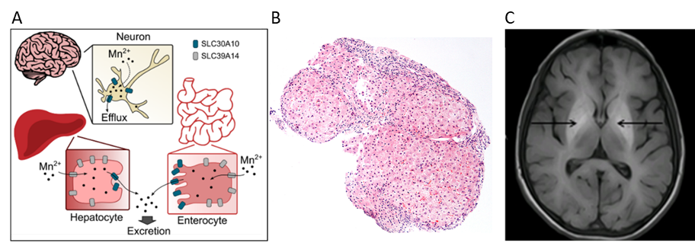
Figure 1. (A) Mechanisms by which SLC30A10 and SLC39A14 regulate manganese homeostasis. SLC39A14 facilitates uptake of manganese into hepatocytes and enterocytes for subsequent excretion via SLC30A10.4 (B) Histological appearances (H&E) of liver cirrhosis in patients with SLC30A10 mutations. (C) Characteristic MRI brain appearances of manganese accumulation causing T1-hyperintensity of the globus pallidus (arrows).^{1,2}

Current treatment of manganese overload is limited to chelation with calcium disodium edetate (EDTA).¹⁻² While life-long therapy can improve motor symptoms and halt liver disease, the risk of liver decompensation and neurological sequelae persist. The need for monthly intravenous administration over five days and associated adverse effects make EDTA a poor drug for clinical application, aggravating the disease burden. Blood manganese levels poorly correlate with disease severity and treatment efficacy. Therefore, there is an immense clinical need to identify suitable disease biomarkers and develop alternative therapeutic approaches.
We have demonstrated the crucial role of SLC30A10 in manganese homeostasis across vertebrates with loss-of-function leading to manganese overload in the liver and brain with associated neurotoxicity (Figure 2).^{1,2}
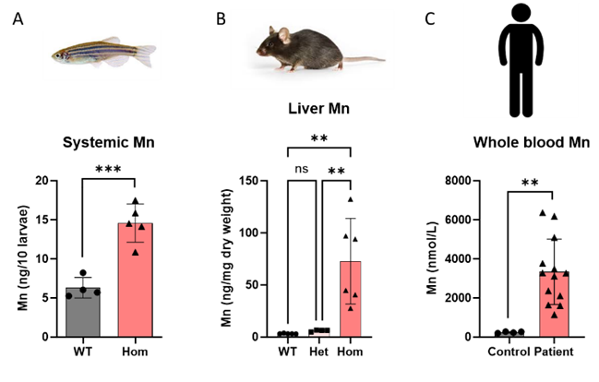
Figure 2. SLC30A10 loss-of-function leads to severe manganese overload in vertebrates including (A) zebrafish (p.[L100Sfs*7]), (B) mice (deletion exon 3-4) and (C) patients with mutations in SLC30A10. Data displayed as mean ± SD. **, P ≤ 0.01; ***, P ≤ 0.001. WT, wildtype; Het, heterozygous; Hom, homozygous.

Observations across disease models suggest that manganese toxicity causes oxidative stress, mitochondrial dysfunction, endoplasmic reticulum stress and Ca²⁺ dysregulation, leading to altered resting-state neuronal activity (Figure 3).⁴ However, the key molecular event(s) and the hierarchical interactions between them remain unknown.
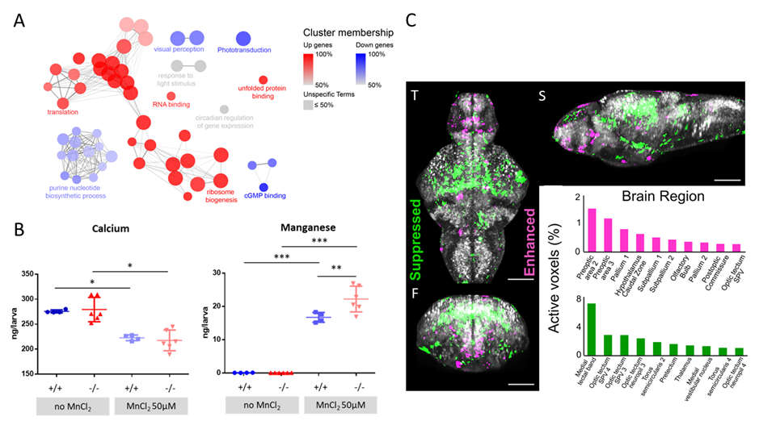
Figure 3. Downstream effects of manganese neurotoxicity. (A) ClueGO network diagram of the enrichment of GO terms from differential gene expression observed in slc39a14-/- zebrafish larvae upon Mn exposure. Nodes represent enriched GO terms and edges connect nodes that share annotations to the significant genes. The sizes of the circles represent the adjusted P-values for each GO term (Wald test). (B) Calcium and manganese concentrations in untreated and MnCl2 treated wild-type and slc39a14−/− larvae. (C) Z-projection of cfos mRNA expression in the brain of slc39a14-/- larvae upon Mn exposure showing brain regions with enhanced (magenta) and suppressed (green) neuronal activity. T, transverse; S, sagittal; F, frontal view. Scale bar 100µM.⁴

Aims/Objectives:
This project aims to better understand the mechanisms underlying manganese homeostasis with the view to identifying novel disease biomarkers and therapeutic approaches for inherited manganese transporter defects and neurodegenerative disorders associated with manganese overload.
• Objective 1: Characterisation of the manganese overload phenotypes of SLC30A10 loss-of-function cell models to determine key players in manganese toxicity and identify readouts for drug testing.
• Objective 2: Determine whether SLC30A10 mRNA therapy can rescue manganese overload phenotypes identified in Objective 1.
• Objective 3: Identification of novel regulators of manganese homeostasis and disease biomarkers using cell models from objective 1 and patient serum.
Methods:
Objective 1 (month 1-12):
Hep3B (shared by Prof Bartnikas, Brown University, US)⁵ and SH-SY5Y cells (GenScript) that carry loss-of-function mutations in SLC30A10 will undergo multi-scale phenotypical characterisation to identify the molecular and biological pathways affected by manganese toxicity. The chosen cell lines are the most relevant to examine manganese dyshomeostasis since both liver and brain (dopaminergic neurotransmission) are affected in HMNDYT1. Phenotypical characterisation at baseline and upon MnCl₂ exposure will include:
- Survival analysis.
- Multi-element Inductively Coupled Plasma-Mass Spectrometry (ICP-MS) analysis (Mn, Ca, Fe, Zn).
- ⁵²Mn uptake and efflux studies.
- Manganese distribution: Fura-2, M1 Mn²⁺ sensor.
- Calcium homeostasis: Ca-NPEGTA, Rhod-5n, Fura-2.
- Oxidative stress: probes for ROS, OH·, lipid peroxidation, glutathione.
- Mitochondrial function: Δψm, respiratory chain activity, oxygen consumption, seahorse analysis.
Milestone 1 (month 12): Readouts for drug testing identified.
Cell models will be used for proteomic studies in objective 3.
Objective 2 (month 13-18):
Phenotypical read-outs identified under objective 1 will be used to assess the pharmacokinetics and efficacy of SLC30A10 mRNA therapy (unformulated and LNP encapsulated provided by commercial partner Moderna):
- Protein expression and subcellular localisation will be confirmed longitudinally over 7 days using Western blot and immunohistochemistry.
- Manganese concentration and flux will be determined by ICP-MS and ⁵²Mn flux studies (collaborator Prof Blower, KCL).
Milestone 2 (month 18): Functional rescue of Mn overload phenotypes and duration of effect of mRNA therapy confirmed in vitro.
Objective 3 (month 13-30):
Proteomic analysis will be performed on control, SLC30A10 KO and mRNA treated Hep3B/SH-SY5Y cells using label free proteomic techniques:
1. with fractionated lysate digests for deep proteome coverage.
2. after enrichment of manganese binding proteins using Immobilized Metal Chelate Affinity Chromatography (column charged with Mn²⁺).
This will identify changes in protein expression upon manganese overload. Identified candidate proteins or metabolites will be validated in control and patient serum using multiplex targeted LC-MS/MS assays with the view to developing novel biomarkers for disease monitoring.
Protein candidates and hierarchical interactions between them will be further explored in cell models established in objective 1 (e.g. using inhibitors of biological pathways/Ca²⁺ flux).
Milestone 3 (month 24): Lead candidates identified.
Milestone 4 (month 30): Verification of candidates in control/patient serum.
Milestone 5 (month 30): Possible hierarchical interactions of manganese toxicity effects determined.

Timeline: 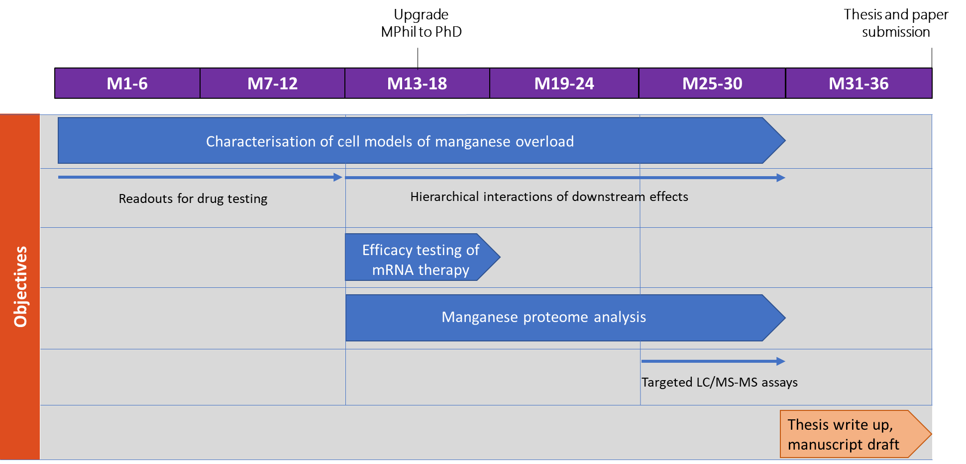
Figure 4. Gantt chart illustrating timeline and work packages.
Collaborations:
- This project is supported by the GOSH BRC supported UCL Biological Mass Spectrometry Centre and supervision in these techniques through subsidiary supervisor Dr Wendy Heywood.
- Prof Phil Blower and PDRA Dr George Firth, KCL, will provide the radionuclide ⁵²Mn as well as training required for the proposed manganese flux studies.
- The Abramov lab at UCL IoN will share their expertise in cell physiology to assess mitochondrial function, oxidative stress and Ca homeostasis in our cell models.
- Commercial partner Moderna will provide unformulated and LNP encapsulated SLC30A10 mRNA as in kind contribution.
These collaborations will ensure that the student will be provided with excellent training across multiple disciplines and methodologies required to achieve the set objectives.

Plans for patient and public involvement and engagement for the project/student:
Public engagement will be an integral part of this PhD studentship. The student will be encouraged to participate in Impact and Engagement Training provided by UCL Engagement (https://www.ucl.ac.uk/culture/ucl-engagement/training). GOSH and ICH have frequent public engagement events that we will attend (e.g. NIHR GOSH BRC Open Day, GOSHCC family events). Engagement with the GOSH Young People Advisory Group, that has been consulted by Dr Tuschl/Prof Mills previously, will be continued. In addition, we will work closely with the UCL Public Engagement Unit, communications officers at ICH/GOSH and NIHR GOSH BRC who provide support to optimise public engagement and dissemination of results. We further engage with charities (Rare Disease UK, Genetic Alliance UK, NORD and Action Medical Research) to develop rare disease information on inherited manganese transporter defects for patients and caregivers.

References:
1. Tuschl K, Clayton PT, Gospe SM Jr, Gulab S, Ibrahim S, Singhi P, Aulakh R, Ribeiro RT, Barsottini OG, Zaki MS, Del Rosario ML, Dyack S, Price V, Rideout A, Gordon K, Wevers RA, Chong WK, Mills PB. Syndrome of hepatic cirrhosis, dystonia, polycythemia, and hypermanganesemia caused by mutations in SLC30A10, a manganese transporter in man. Am J Hum Genet. 2012;90:457-66.
2. Tuschl K, Meyer E, Valdivia LE, Zhao N, Dadswell C, Abdul-Sada A, Hung CY, Simpson MA, Chong WK, Jacques TS, Woltjer RL, Eaton S, Gregory A, Sanford L, Kara E, Houlden H, Cuno SM, Prokisch H, Valletta L, Tiranti V, Younis R, Maher ER, Spencer J, Straatman-Iwanowska A, Gissen P, Selim LA, Pintos-Morell G, Coroleu-Lletget W, Mohammad SS, Yoganathan S, Dale RC, Thomas M, Rihel J, Bodamer OA, Enns CA, Hayflick SJ, Clayton PT, Mills PB, Kurian MA, Wilson SW. Mutations in SLC39A14 disrupt manganese homeostasis and cause childhood-onset parkinsonism-dystonia. Nat Commun. 2016;7:11601.
3. Budinger D, Barral S, Soo AKS, Kurian MA. The role of manganese dysregulation in neurological disease: emerging evidence. Lancet Neurol. 2021;20:956-968.
4. Tuschl K, White RJ, Trivedi C, Valdivia LE, Niklaus S, Bianco IH, Dadswell C, González-Méndez R, Sealy IM, Neuhauss SCF, Houart C, Rihel J, Wilson SW, Busch-Nentwich EM. Loss of slc39a14 causes simultaneous manganese hypersensitivity and deficiency in zebrafish. Dis Model Mech. 2022;15:dmm044594.
5. Prajapati M, Pettiglio MA, Conboy HL, Mercadante CJ, Hojyo S, Fukada T, Bartnikas TB. Characterization of in vitro models of SLC30A10 deficiency. Biometals. 2021;34:573-588.

BRC Theme: Tissue Engineering and Regenerative Medicine

Project T1
Project title: Role of mechanical signals in a 3D human model of alveolar differentiation
Supervisory Team:
Dr Stavros Loukogeorgakis, UCL Great Ormond Street Institute of Child Health (primary)
Dr Federica Michielin, UCL Great Ormond Street Institute of Child Health (subsidiary)
Professor Paolo De Coppi, Great Ormond Street Hospital (subsidiary)

Contact: Federica Michielin - f.michielin@ucl.ac.uk
Background:
Alveolar epithelial type I (AT1) and type II (AT2) cells are essential for normal lung function following birth. Abnormal differentiation of AT1 and AT2 cells during development results in pulmonary pathology with associated neonatal mortality and long-term morbidity.
AT1 cells are flat cells responsible for gas exchange and are highly sensitive to mechanical forces, whereas AT2 cells are secretory cells that reduce surface tension during breathing. The impact of mechanical signals during fetal lung development is increasingly being recognised as key determinant of progenitor cell fate. In fact, mechanical signals from amniotic fluid pressure are crucial in specifying bud tip progenitor cells into AT1/AT2 fates with a specific ratio¹.
Alterations of mechanical loads are common to several fetal lung pathologies, such as that associated with Congenital Diaphragmatic Hernia (CDH; incidence 1 in 2,500 live births), Bronchopulmonary Dysplasia (BPD) and oligohydramnios. In CDH, pulmonary development is impaired by the direct compression of the lung by abdominal organs herniated into the thoracic cavity. This causes an abnormal stiffening of the lung parenchyma, lung hypoplasia and, consequently, impaired alveolar development.

We have recently developed a purely mechanical model of fetal lung compression; in this model, lung tissue in culture is confined peripherally (i.e. exposed to increasing stiffness at the distal/growing parts of the lung) resulting in hypoplasia similar to that observed in human CDH (Loukogeorgakis*, Michielin* et al., submitted). To further investigate the mechanisms by which mechanical stiffness leads to altered AT1/AT2 differentiation, we have also developed a mouse in vitro model based on 3-dimensional (3D) lung organoids that are induced to differentiate towards the alveolar fate with modulation of stiffness levels in the extracellular environment. Stiffness modulation is performed through an innovative 3D-printing technique that we and others pioneered². Our preliminary work with this model demonstrated that mechanical alterations of the extracellular environment are sufficient to induce impairment of alveolar differentiation by altering cell cytoskeletal tension (Michielin et al., in preparation). Specifically, we found a decreased alveolar commitment of tip progenitor cells, along with impaired proliferation, consistently with the lung hypoplasia and alveolar simplification observed in human CDH.

We now want to translate this experimental setup to a human model of alveolar differentiation and identify targets to promote alveolar development relevant for clinical translation. To date, human models that recapitulate alveologenesis in vitro are missing. This is mainly due to the constraint of tissue availability beyond 21 weeks of gestation and particularly during the saccular and canalicular stages when alveolar commitment occurs. Consequently, the development of a protocol of alveolar differentiation to obtain both AT2 and AT1 cells from AT2 progenitor organoids derived from human cells is also needed.

Aims/Objectives:
The aim of this project is to investigate the contribution of mechanical stiffness on the onset of human alveolar specification and further differentiation. The key questions will be: i) How pathological stiffness alters AT1/AT2 differentiation and maturation? ii) To what extent cytoskeletal tension contributes to this alteration?
To address these questions the specific objectives will be:
1. To develop a 3D in vitro model of human alveolar differentiation.
2. To investigate the impact of mechanical stiffness on alveolar commitment and maturation of AT1 and AT2 cells.
3. To identify mechano-responsive targets of alveolar commitment, including the investigation of a stiffness-induced cytoskeletal remodelling and its underlying mechanism.

Methods:
Protocol development.
Human induced pluripotent stem cells (hiPSCs) will be used to model alveolar differentiation starting from an already developed protocol to generate AT2 progenitors alveolospheres³. A double reporter NKX2.1-GFP/SFTPC-TdTomato hiPSC line will be used to monitor the differentiation efficiency into AT2 progenitor cells. Then, a further differentiation protocol to obtain both AT2 and AT1 cells from AT2 progenitor organoids will be developed and optimized to obtain mature AT1 or AT2 cells, respectively. This includes the use of air-liquid interface, the co-culture with fibroblasts, and the manipulation of Wnt signaling. Maturation of AT1 cells will be evaluated at different time points of differentiation by analysing the degree of cell flattening, whereas AT2 maturation will be evaluated by quantification of secreted surfactant proteins through ELISA assay. The developed protocol will be also validated by using amniotic fluid-derived lung organoids that we recently described for the first time⁴, and already available in our laboratory.

Assessment of stiffness-dependent alveolar differentiation.
Organoids will be differentiated in 3D matrix with defined mechanical properties. Matrix stiffness will be tuned using Matrigel as a substrate of physiological stiffness, along with mixtures of Matrigel and chemically modified polyethylene-glycol gels (PEG-HCC)². Increasing stiffness of Matrigel/PEG-HCC mixtures will be achieved according to the nature of the gel (4- or 8-arm-PEG), its concentration and the UV light dosage used for the crosslinking. Alveolar differentiation will be assessed by qPCR, flowcytometry and Immunofluorescence (IF) at shorter (7 days) and longer time-points (14 days), to evaluate the presence of AT1 and AT2 cells, along with subpopulations with mixed phenotypes.

Target identification.
Single-cell RNA-sequencing (scRNAseq) analysis will be used to investigate cell identity at different stiffness and time points during differentiation and compared with published dataset of lung development⁵ to identify normal and altered cell identities. ScRNAseq data will be coupled to bulk ATAC-sequencing (ATACseq) to identify key transcription factors of alveolar differentiation associated to mechanical stimulation. Alteration of the alveolar commitment will be confirmed through immunohistochemistry analysis of CDH postmortem cases already available at GOSH, along with cases with no CDH at the same developmental stages as normal controls.
Then, the contribution of different cytoskeletal components to stiffness-induced alveolar patterning will be further investigated by using different cytoskeletal inhibitor drugs to specifically target actin filaments (Latrunculin, Cytochalasin), myosin (Y27632, Blebbistatin) and intermediate filaments (Nocodazole, Withferin) with the purpose of decreasing the stiffness-induced cytoskeletal tension and restoring the normal differentiation pattern.

Timeline:
Year 1: Development and optimization of the alveolar differentiation protocol from hiPSC; protocol validation; immunohistochemistry analysis of CDH postmortem cases.
Year 2: Characterization of the stiffness-dependent alveolar differentiation; scRNAseq and ATACseq experiments.
Year 3: Bioinformatic analysis of scRNAseq and ATACseq; target validation with CDH postmortem cases; cytoskeletal inhibitor drugs testing.

Collaborations:
Nicola Elvassore (University of Padova)

Plans for patient and public involvement and engagement for the project/student:
Due to the translational nature of this basic science project, we will ensure that PPIE will have prominent contribution to the project and the activities of the student. Through our NHS-commissioned fetal surgery service at UCLH/GOSH/UZ Leuven, we have established a close relationship with the UK CDH patient association (CDH UK; https://cdhuk.org.uk/). They would be our primary PPIE partners, given that CDH-associated lung pathology is our primary disease target. They have had long-standing involvement in (and have previously funded) CDH-related research in our laboratory. The unique resources available at the NIHR GOSH BRC will facilitate PPIE training for the student and enhance PPIE plans/activity in the project.

References:
- Li, J. et al. The Strength of Mechanical Forces Determines the Differentiation of Alveolar Epithelial Cells. Dev. Cell 44, 297-312.e5 (2018).
- Urciuolo, A. et al. Hydrogel-in-hydrogel live bioprinting for guidance and control of organoids and organotypic cultures. Nat Commun 14, 3128 (2023).
- Jacob, A. et al. Derivation of self-renewing lung alveolar epithelial type II cells from human pluripotent stem cells. Nat. Protoc. 14, 3303–3332 (2019).
- Gerli, M. F. M. et al. Single cell-guided prenatal derivation of primary epithelial organoids from the human amniotic and tracheal fluids. 2023.05.31.539801 Preprint at https://doi.org/10.1101/2023.05.31.539801 (2023).
- Zepp, J. A. et al. Genomic, epigenomic, and biophysical cues controlling the emergence of the lung alveolus. Science 371, eabc3172 (2021).

Project T2
Project title: AI-assisted diagnosis, surgical planning & implant design for craniofacial patient care
Supervisory Team:
Professor Silvia Schievano, UCL Institute of Cardiovascular Sciences and UCL Great Ormond Street Institute of Child Health
Dr Juling Ong, Great Ormond Street Hospital
Professor Owase Jeelani, Great Ormond Street Hospital

Contact: Silvia Schievano - s.schievano@ucl.ac.uk
Background:
Craniofacial diseases, particularly in craniosynostosis cases, present significant challenges in diagnosis and treatment. These disorders - impacting approximately 1 in 1,700 live births [1] - result in abnormal growth of cranial and facial bones due to premature fusion of the cranial sutures restricting natural skull expansion [Fig 1].
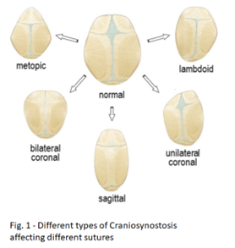
This can translate into several dysfunctions, raised intracranial pressure, neurodevelopmental delays, breathing difficulties & aesthetic concerns, amongst others [2]. Corrective surgeries, spanning from minimally invasive to traditional cranial vault remodelling, aim to remodel the skull, allowing appropriate brain growth and rectifying deformities [3, Fig 2].
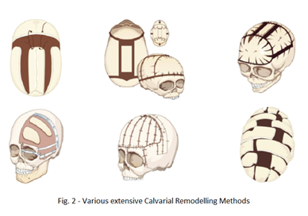
Nevertheless, despite their instrumental role, these methodologies have limitations in predicting outcomes, ensuring long-term stability and achieving complete aesthetic normalisation. Patients experience secondary complications post-surgeries such as bone resorption, asymmetry recurrence, or inadequate correction of cranial deformities that may require additional interventions [4].

In such cases, custom prosthesis implants are manually crafted to the patient's specific craniofacial contours to address these issues, serving as adjunctive tools in correcting residual deformities [5]. However, due to the intrinsic bespoke nature of each implant, a significant level of variability exists across anatomical locations [6], making outcome prediction challenging and success highly dependent on the expertise of the designer /operating surgeon [Fig 3]. Thus, the implants’ goal, i.e. integration with existing cranial structures and long-term stability, is undermined by uncertainty. Additionally, often the entire process is completely in the hands of the experts (mainly design engineers and surgeons) with little or no input from the patients / families.
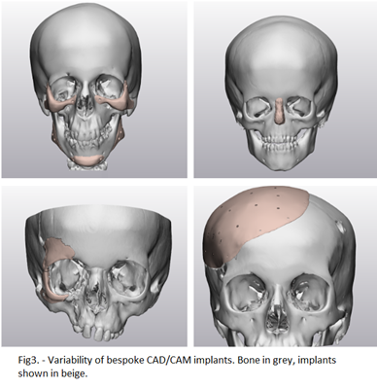
Aims/Objectives
The overall goal of this project is to revolutionise delivery of craniofacial surgery through development and implementation of engineering methodologies for the benefit of children born with craniofacial abnormalities worldwide. The specific objectives are:
1. To develop, validate and implement 3D photography as a dual-purpose clinical tool both to reduce radiation exposure and to facilitate distributed diagnosis and monitoring throughout patient care.
2. To optimise clinical 3D CAD/CAM implant design and virtual surgical planing processes via computational simulations.
3. To develop patient-centric treatment design processes and a communication platform, through use of AI and community engagement.

Methods
WP1 - Remote 3D photography
1.1 - Retrospective Clinical Data Collection
1.2 - Pilot and validate 3D photo tools against established 3D Photo hardware
1.3 - Establish a patient-centric 3D photography server within existing patient portals to enable distributed diagnosis and monitoring.
WP2 - Implant Design and Surgical Planning
2.1 - Analyse pre- and post-op scans/3D photos of patients with 3D CAD/CAM implants to refine surgical planning.
2.2 - Develop a finite element model for unified soft tissues surrounding craniofacial implants to optimise planning accuracy.
2.3 - Parametrise synthetic implants based on validated soft tissue simulations for improved implant design.
2.4 - Community Input for simulation presentation / interface
WP3 - AI for Patient-Centric Treatment Design
3.1 - Train AI algorithms on synthetic data to expedite and refine design of clinical implants.
3.2 - Develop bottom-up design process utilising AI to incorporate patient / parental input into treatment planning.
3.3 - Conduct focus group workshops to gather user experiences and feedback for iterative, patient-centric treatment design process.
3.4 - Evaluate & refine the designed treatment process with community input, focusing on surgical design, and community engagement

Timeline
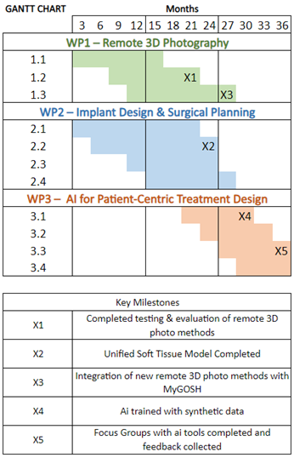

Collaborations
The PhD student will have the opportunity to be part of the Craniofacial Research Unit at GOSH & UCL, to collaborate with other PhD students, postdoctoral researchers and clinicians, and contribute to the group research under the supervision of Prof. Schievano, Mr Ong, Prof. Jeelani, Prof. Dunaway and Dr Alessandro Borghi, who has recently joined Durham University as Assistant Professor. This multidisciplinary team will be the main collaborators for the research project.

National collaborations are established with other research and clinical units, in particular with clinicians from the four supra-regional Units specialising in Craniofacial Surgery. Furthermore, the Craniofacial Units in London, Birmingham & Liverpool have begun an initiative on setting up a shared data repository for craniofacial cases. This, together with the synergies fostered by the BRC Paediatric Excellence Initiative opens the possibility to enable addition of data from other units (dependent on governance and consenting), and potentially further collaborative work.

Interactions with other several craniofacial centres around the world will be crucial to ensure that the research developed during this project will remain relevant for translation into other clinical settings. We are a member of the European Reference Network for craniofacial treatment (ERN CRANIO). ERN CRANIO aims to pool together disease-specific expertise, knowledge and resources from across Europe to achieve health goals that may otherwise be unachievable in a single country, such as standardisation of 3D Photography captures, processing & analysis. A protocol for comparison of scanning and processing methodologies has been drafted and work is underway to assess and quantify the inter-centre differences. This work and the network itself will be important to develop and trial the use of remote 3D photography, part of this proposal.

Plans for patient and public involvement and engagement for the project/student
Collaboration, engagement and involvement of the various stakeholders, including patients, families, clinicians both nationally and internationally, and industry partners will be pivotal throughout the research project as its ultimate goal is to deliver patient centred care in paediatric craniofacial surgery. Engaging with relevant clinical units and patient support groups will aid in reaching a larger audience and gathering diverse perspectives.

Community Accessibility and Diversity: Emphasising inclusivity, the project aims to engage diverse communities affected by craniofacial anomalies. Efforts will be made to ensure accessibility to information and participation in focus groups and workshops across different cultural backgrounds, races and group ages.

Focus Groups and Workshops: The plan involves conducting focus groups and workshops to gather user experiences and feedback, fostering an iterative, patient-centric treatment design process. This engagement will allow for clearer communication and collaboration among patients, parents/guardians, clinicians, and researchers.

Patient Involvement in Treatment Planning: The initiative recognizes the importance of patient input in treatment decisions. AI tools will be utilised to incorporate patient and parental input into treatment planning, empowering patients to contribute to their care process.

Transparency and Education: The communication plan aims to ensure transparency in research practices and outcomes. It will include educational materials to inform patients, families, and the public about the advancements in craniofacial anomaly care achieved through the project.

Information Dissemination: Efforts will be made to disseminate findings through various channels, including scientific publications, conferences, and potentially through lay summaries and newsletters to make the research accessible to a wider audience.

Ethical and Regulatory Considerations: To address privacy concerns and ethical standards, the project plans to conduct a Data Protection Impact Assessment (DPIA) in compliance with information governance. Additionally, necessary ethical approvals will be obtained for the collection and use of patient data.

References
- Forbes BJ. Congenital craniofacial anomalies. Curr Opin Ophthalmol. 2010;21(5):367-74
- Fearon JA. Evidence-based medicine: craniosynostosis. Plast Reconstr Surg 2014;133(5):1261-75
- Park DH, Yoon SH. Craniofacial malformation treatment: Craniosynostosis and positional plagiocephaly. Journal of Korean Medical Association. 2012 Sept;55(9):878
- Rodriguez-Florez N, Florez-Tapia A, Jeelani NUO, Schievano S, Dunaway DJ, Hayward RD. Investigating the cause of late deformity following fronto-orbital remodelling for metopic synostosis using 3D CT imaging. J Craniomaxillofac Surg. 2019 Jan;47(1):170-178
- Eufinger H, Wehmöller M, Machtens E, Heuser L, Harders A, Kruse D. Reconstruction of craniofacial bone defects with individual alloplastic implants based on CAD/CAM-manipulated CT-data. J Craniomaxillofac Surg. 1995 Jun;23(3):175-81

Project T3
Project title: Vascularising human mini-brains in a dish
Supervisory Team:
Dr Paula Alexandre, UCL Great Ormond Street Institute of Child Health (primary)
Professor David Long, UCL Great Ormond Street Institute of Child Health (subsidiary)

Contact: Paula Alexandre - p.alexandre@ucl.ac.uk
Background:
Blood vessels play a pivotal role in brain development and function. They promote tissue growth and survival by supplying nutrients and oxygen to surrounding tissues, signals to progenitor populations, as well as guiding neuronal migration. Vascular defects are associated with brain disorders such as epilepsy and neurodegenerative diseases. However, we don’t fully understand how blood vessels influence brain development and, conversely, how brain cells can influence angiogenesis.
Alexandre’s lab has been investigating the development of the human hindbrain (Haldipur et al, 2019) and growing human hindbrain organoids derived from induced pluripotent stem cells (iPSCs) (Silva et al, 2020) from control and Down Syndrome. Long’s lab brings extensive expertise in growing iPSC cell models and most recently, vascular organoids. His lab has proven expertise in tissue clearing methods, 3D imaging and quantification methods to study patterns of vascularisation (Jafree et al, 2019).
This project aims to vascularize hindbrain organoids and assess the influence of blood vessels on neurogenesis in both healthy and Down syndrome iPSC-derived organoids. Abnormal vascularisation has been reported in Down syndrome, and our initial aim is to test whether the defects in Down Syndrome vascularisation result from intrinsic signals or from the extrinsic factors provided by the brain cells.
The supervisory team has all the required expertise and reagents for the project.
Aims/Objectives:
Our aims are:
1) Promote vascularisation of healthy hindbrain organoids
2) Determine the impact of vascularisation in healthy derived hindbrain organoids.
3) Investigate the interactions between brain cells and vasculature in Down Syndrome.
The generation of vascularized brain organoids promises a ground-breaking impact across diverse disciplines. They enable precise modelling of human developmental brain disorders, delineate vascularised niches in brain tumours, and facilitate testing of novel therapies for diseases like brain degenerative disorders and paediatric brain tumours.
Methods:
Endothelial and neural cells originate from distinct embryonic layers, the mesoderm and ectoderm respectively, presenting a challenge in their simultaneous differentiation within organoid models. To address this, we propose a sequential approach wherein organoids are grown separately and then co-cultured post-differentiation to promote their healthy development and survival.
In Aim 1, we will explore both in vivo and in vitro strategies. In vivo, we aim to transplant GFP-expressing hindbrain organoids into human brain explants and culture these for 1-2 weeks. The GFP will allow us to distinguish between organoids and human brain cells. In vitro, we will culture vascular organoids within hydrogels containing various extracellular matrix components while hindbrain organoids are grown in neural media but in close contact with the vascular setup. If successful, we will progress to microfluidics in a microchip configuration (see Fig1).
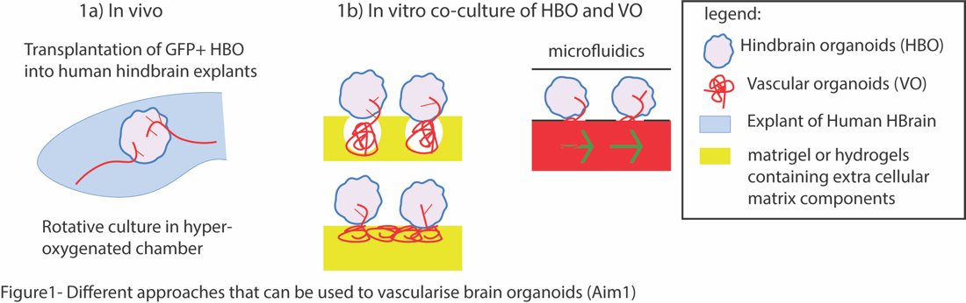
In Aim 2, vascularized organoids will undergo immunohistochemistry clearing procedures and 3D imaging to investigate the extension and pattern of vascularization, cell proliferation, organoid growth, and cellular output when compared to non-vascularized organoids our ongoing work on the developing human hindbrain (CD34-blood vessel marker, mKi67-proliferative marker, ELAVL4-neuronal marker, etc).
Once optimal co-culture conditions are established, hindbrain and vascular organoids from both healthy and Down Syndrome subjects will be co-cultured in different combinations to delineate whether vascularization defects arise from blood vessels or neural cells (Aim3). Assessment of the phenotype will involve histological and comparative analysis between the different co-culture systems and human developing hindbrain structures.
We are currently generating detailed single cell transcriptomic data from both healthy control and Down syndrome organoids that will complement the current study.
Timeline:
Year1: focus on optimising the co-culture systems (aim1).
Year2: continue optimising the co-culture systems (aim1) and analysing the changes on cellular output (aim2). It also starts analysing the phenotype in Down Syndrome (aim3).
Year3: continue the analysis of Down Syndrome (aim3), write the manuscript and thesis.
Collaborations:
Collaborators that can provide input into the project:
Professor Paolo de Coppi and Dr Giovanni Giobe at UCL GOS ICH, are experts in Stem cell and bioengineering approaches.
Professor Kathleen Milen and Dr Parthiv Haldipur are experts in human hindbrain development and brain malformations.
Plans for patient and public involvement and engagement for the project/student:
The student will have diverse opportunity to be involved in PPIE, including involvement in GOSH BRC events such as Family Fun Day and Playstreet. The Alexandre/Long groups are also involved in public engagement through outreach events for 16-18-year-olds interested in STEM, through the HDBI Inspire programme and the ICH Work Experience Scheme. Finally, the student will engage with patients through the LonDowns meetings and discuss the progresses in the field with clinicians, researchers and families from children with Down Syndrome.
References:
1- Haldipur P, Aldinger KA, Bernardo S, Deng M, Timms AE, Overman LM, Winter C, Lisgo SN, Razavi F, Silvestri E, Manganaro L, Adle-Biassette H, Guimiot F, Russo R, Kidron D, Hof PR, Gerrelli D, Lindsay SJ, Dobyns WB, Glass IA, Alexandre P, Millen KJ. Spatiotemporal expansion of primary progenitor zones in the developing human cerebellum. Science. 2019 Oct 25;366(6464):454-460. doi: 10.1126/science.aax7526
2- Silva T. P., Bekman, E. P., Fernandes, T. G., Vaz, S. H., Rodrigues, C. A. V., Diogo, M. M., Cabral, J. M. S., & Carmo-Fonseca, M. (2020). Maturation of Human Pluripotent Stem Cell-Derived Cerebellar Neurons in the Absence of Co-culture. Frontiers in Bioengineering and Biotechnology, 8(Stem Cell Systems Bioengineering). https://doi.org/10.3389/fbioe.2020.000870
3- Daniyal J Jafree, Dale Moulding, Maria Kolatsi-Joannou, Nuria Perretta Tejedor, Karen L Price, Natalie J Milmoe, Claire L Walsh, Rosa Maria Correra, Paul JD Winyard, Peter C Harris, Christiana Ruhrberg, Simon Walker-Samuel, Paul R Riley, Adrian S Woolf, Peter J Scambler, David A Long (2019) Spatiotemporal dynamics and heterogeneity of renal lymphatics in mammalian development and cystic kidney disease eLife 8:e48183

Project T4
Project title: Optogenetic sculpting of next-generation organoids for disease modelling of congenital malformations including spina bifida
Supervisory Team:
Dr Gabriel Galea, UCL Great Ormond Street Institute of Child Health (primary)
Professor Jane Sowden, UCL Great Ormond Street Institute of Child Health (subsidiary)

Contact: Gabriel Galea - g.galea@ucl.ac.uk
Background
The ability to generate human induced pluripotent stem cells (iPSC) from adult cell types has revolutionised regenerative medicine research. Well-established 3D iPSC aggregates –called organoids – recapitulate many properties of human tissues. Several organoid systems are currently being used for disease modelling and some may form future therapies; for example by secreting proteins (e.g. insulin) absent in patients, or as sources of cells for transplantation. A common, major limitation of organoid technologies is their unpredictable development of highly variable shapes. For example, to study failures of embryonic development underlying congenital malformations, we need models which reliably produce embryo-like shapes to accurately position cells with different functions. Inherent variability stops organoids from being used to model these conditions by comparing development of cells from patients versus healthy controls.
Correct development of structures including the retina, brain and spinal cord all require carefully orchestrated changes in the shape of tissues, which requires coordinated changes in the shape of cells in embryos. iPSCs can be differentiated into embryonic cell types such as neuroepithelial cells (e.g. Ampartzidis et al Dev Biol 2023), but do not predictably and uniformly form 3D shapes as they do in vivo. Approaches to guide tissue shapes in culture include creating physical hydrogels which constrain them (e.g. Urciuolo et al Nat Commun 2023) or limiting the starting geometry of cell aggregates with micropatterns (e.g. Karzbrun et al Nature 2021). A novel and exciting alternative option is to use optogenetics to reversibly control cell shape and resulting behaviour.
Optogenetic technology uses genetically-encoded proteins which can be triggered to change their conformation by exposure to different wavelengths of light. This can be used to activate or change the location of proteins. Optogenetic constructs which target the Rho/ROCK pathway can cause cellular contraction. For example, optic vesicles made of embryonic stem cells expressing an optogenetically-activated ROCK activator can be forced to curve or flatten when triggered with light (Martínez-Ara et al Nat Commun 2022). The same tool has been used to force flat cultures of epithelial cells to curl up into a tube, much like neuroepithelial cells do with the neural tube which makes the embryonic central nervous system. Constricting cells also stretch other cells attached to them, providing mechanical cues to which many cells can respond by changing gene expression. For example, stretched cells commonly activate the mechano-responsive transcription factor YAP which increases cell proliferation. This may provide a method to mechanically pattern cell signalling which induces proliferation. The systems to envisage applying this technology to are both related to functions of neuroepithelial cells: spina bifida (Dr Galea) and eye development (Prof Sowden).
We are now looking for a PhD applicant, with expertise in cell culture, to develop optogenetic tools for disease modelling applications.
Aims/Objectives:
The proposed project is designed to progressively increase in complexity, guided by the student’s discoveries and interests. During the project, the student will:
1. Optimise optogenetic control of epithelial cell shape using published optogenetic constructs applied to immortalised cell lines.
2. Apply optogenetic stimulation to pattern mechanically-initiated cell signalling, such as may be needed to locally modulate cell proliferation or differentiation during organoid development.
3. Develop methods to optogenetically control the shape of iPSCs and their neuroepithelial derivatives, for example through CRISPR modification.
4. Apply optogenetic control of cell contractility to improve the reproducibility of iPSC-derived neuroepithelial structures, such as optic vesicles (relevant to coloboma and retinal transplantation) and neural tube models (relevant to spina bifida).
Methods:
Previously-published optogenetic constructs will be used – the Galea lab has modified one of these to render it Cre-inducible in order to increase control over its activity. The student will be trained to use the Institute’s advanced microscopes, including a Nikon Ti2 dedicated live-imaging system with machine learning-powered feature detection. They will initially use immortalised epithelial cell lines to compare optogenetic constructs and their cellular effects using transient transfection, potentially progressing to selection of stably transfected clones or CRSIPR-mediated genomic insertion. iPSC work will be carried out in control lines with fluorescent markers labelling their differentiation status, and/or patient-derived lines to model conditions including spina bifida.
Timeline:
Objectives 1 and 2 should be completed in time for the student’s MPhil to PhD upgrade (12-14 months). Objectives 2 and 3 are expected to take approximately 9 months each, leaving approximately six months to follow exciting findings and write the PhD thesis. The principal supervisor encourages students to publish a small manuscript early in their training, assuming they generate suitable data, to gain experience of the publication process, then aim to publish a larger second manuscript later in the PhD.
Collaborations:
This will be a highly collaborative project involving working with members of the Galea lab to learn neuroepithelial biology and biomechanics, members of the Sowden lab to learn genetic engineering techniques and eye development, and external collaborators such as Prof Nicola Elvassore (University of Padua, stem cell and bioengineering expert).
Plans for patient and public involvement and engagement for the project/student:
The student would be expected to contribute to patient and public engagement activities organised by the Galea lab as well as taking part in institutional activities such as the 3-Minute Thesis competition. Examples of previous Galea lab patient and public engagement include collaborations with the Shine charity for spina bifida and hydrocephalus (e.g. https://www.facebook.com/ShineUKCharity/posts/shine-is-grateful-for-the-opportunity-to-join-forces-with-drgabriel-galea-ucl-in/2338798786214404/), and local activities such as the GOSH Rare Disease Day.
References:
- Ampartzidis et al Dev Biol 2023
- Urciuolo et al Nat Commun 2023
- Karzbrun et al Nature 2021
- Martínez-Ara et al Nat Commun 2022

Project T5
Project title: Advancing translational cell therapy for Hirschsprung disease
Supervisory Team:
Dr Conor McCann, UCL Great Ormond Street Institute of Child Health (primary)
Professor Paolo De Coppi, UCL Great Ormond Street Institute of Child Health (subsidiary)

Contact: Conor McCann- conor.mccann@ucl.ac.uk
Background
Clinical disorders characterised by neuronal loss or dysfunction in the gastrointestinal tract remain some of the most challenging to manage, with considerable morbidity and mortality and very limited treatments. Hirschsprung disease (HSCR), one such condition, is a life-threatening intestinal disorder affecting 1 in 5000 live births. HSCR is caused by the absence of enteric neurons in the distal bowel which loses propulsive gut motility and ultimately results in intestinal obstruction.¹ The current treatment is surgical resection of the affected bowel combined with a ‘pull through’ procedure, to connect the proximal ganglionated gut to a necessarily retained distal segment of aganglionic ano-rectum. The need to retain this abnormal distal segment accounts, in part, for the life-long gastrointestinal problems suffered by HSCR patients. These problems include constipation, faecal incontinence, and enterocolitis, which significantly contribute to poor quality of life. Surgery, readmissions, and outpatient hospital appointments required for management of HSCR present an ongoing significant burden for the healthcare system.
Recent advances in the understanding of the development of the enteric nervous system (ENS), the intrinsic innervation of the gastrointestinal tract, and the pathogenesis of HSCR have highlighted the potential for cell replacement therapy for this disorder.² During embryogenesis, the ENS is predominantly derived from a transient population of multipotent cells termed neural crest (NC) cells that migrate from the neural tube at the vagal axial level (adjacent to somites 1-7) to colonise and ultimately innervate the gastrointestinal tract. In HSCR these cells fail to colonize a variable length of the distal gut, which remains aganglionic and fails to function. ENS progenitors derived from mouse and human fetal/early postnatal gut have been shown to effectively colonise and differentiate within the ENS of both healthy animals and, most importantly aganglionic gut explants from HSCR disease models and patients. Such preclinical studies have demonstrated that cell therapy could be a viable option for treating HSCR. We have developed a robust protocol for the generation of vagal NC and ENS cell types from hPSCs exhibiting similar behaviour to their in vivo counterparts. This method for the accelerated (6-day) production of ENS progenitors is an improvement over other published protocols which typically require 10-15 days to generate an equivalent cell type.³ Moreover, we have demonstrated that hPSC-derived ENS progenitors generated in using this protocol, can colonise the ENS of immunocompromised (Rag2^{-/-};γc^{-/-};C5^{-/-}) 4-8 week-old mice following transplantation into the caecum.⁴ Most recently, we have gathered promising preliminary data demonstrating the integration of hPSC-derived ENS progenitors in isolated segments of human HSCR diseased aganglionic tissue (discard tissue sourced under fully informed consent at resection) ex vivo and shown their ability to rescue functionality in a human disease context.⁵ These data provide a strong basis for further translational investigation of this cellular product. However, a major limitation, which precludes clinical application of such therapies, remains a lack of knowledge surrounding the effects of immunosuppression on the efficacy of any ENS progenitor therapeutics. Therefore, novel studies are needed to overcome this bottleneck for the development of ENS cell-based therapies.
Aims/Objectives:
This project aims to aim to utilise a proven in vitro ENS progenitor generation protocol to strengthen the pre-clinical basis for a regenerative medicine approach to treat HSCR tissue. The overarching goal of this project is to examine and optimise the capacity of ENS progenitor to integrate within HSCR tissue.
Specifically, this project will:

1) Evaluate the ability of hPSC-derived ENS progenitors to integrate within human HSCR patient-derived gut samples in a novel ex vivo culture system.
Outcome measure: Design and development of a bespoke bioreactor for ex vivo examination of ENS progenitor integration.
2) Examine the effects of current clinical immunosuppression protocols on hPSC-derived ENS progenitors.
Outcome measure: Acquisition of critical translational data related to effects of immunosuppression on hPSC-derived ENS progenitors.
3) Generate “universal” hPSC-derived ENS progenitors to overcome potential immune response barriers.
Outcome measure: Generation and expansion of pool of hypoimmune donor cells that will be used for preclinical testing of “universal” hPSC-derived ENS progenitors
Methods:
1) Evaluate the ability of hPSC-derived ENS progenitors to integrate within human HSCR patient-derived gut samples in a novel ex vivo culture system.
To test the ability of our hPSC-derived ENS progenitors to integrate within human HSCR tissue, the student will transplant candidate hPSC-derived ENS progenitor populations into isolated segments of human HSCR diseased aganglionic tissue ex vivo to examine their functionality in a human disease context. The student will work alongside the De Coppi group to design and generate a bespoke bioreactor allowing long-term ex vivo culture of aganglionic HSCR tissue. Subsequently, “discarded” colonic tissue from GOSH patients, obtained at surgery, under fully informed ethical consent (already obtained), will be used as a “scaffold” to assess the efficacy of donor hPSC-derived cell populations to repopulate aganglionic human HSCR tissue. Such ex vivo cultures are a well-established system within the UCL GOS-ICH group. Integration and functional output of transplanted cells, within recipient colonic tissues, will be assessed using immunohistochemistry, molecular biology techniques and organ bath contractility/calcium imaging.
2) Examine the effects of current clinical immunosuppression protocols on hPSC-derived ENS progenitors.
To examine the response of hPSC-derived ENS progenitors to immunosuppressive agents the student will compare the ability of hPSCs to efficiently generate ENS progenitors (quantitatively defined by expression of key ENS progenitor markers: p75, RET/TRKC) in the presence or absence of clinically relevant immunosuppressants (e.g., Tacrolimus, Cyclosporine A) using cell culture methods. The ability of hPSC-derived ENS progenitors to form key ENS derivatives (e.g., enteric neurons, glia and neuronal subtypes) will be again quantified in the presence of an immunosuppressant protocol in an in vitro setting and within ex vivo transplanted HSCR tissue. To achieve this objective the student will use a combination of immunohistochemistry, fluorescence activated cell sorting (FACS) and transcriptional analyses.
3) Generate “universal” hPSC-derived ENS progenitors to overcome potential immune response barriers.
To generate hypoimmune “universal” hPSC-derived ENS progenitors the student will use gene editing approaches (i.e., CRISPR/Cas9) to target MHC-I and II complexes within a target hPSC line. Following targeting, hypoimmune donor cells will be used to generate hPSC-derived ENS progenitors using our established protocol. The student will subsequently assess the capacity of hypoimmune hPSC to generate ENS progenitors, and their derivatives, compared to a non-targeted hPSC using a combination of immunohistochemistry, FACS and RNAseq approaches in both cell and ex vivo organotypic culture using patient derived HSCR tissue.
Timeline:
Collaborations:
This proposal builds on a long-standing collaboration with University of Sheffield (Dr. Anestis Tsakiridis; Prof Peter Andrews) to develop and assess hPSC-derived ENS Progenitors. The successful candidate will be encouraged to collaborate closely with this grouping throughout the project. The supervisory grouping also has extensive collaborative links across Europe, USA and Asia. Dependent on project progression, there may be the opportunity for the candidate to take part in short placements, within collaborative labs, to aid in the learning of new techniques and knowledge transfer.
Plans for patient and public involvement and engagement for the project/student:
The long-term goal of this project is to provide a viable cell-based therapy for HSCR patients. However, patient/family input into implementation of this potential therapy will be critical for clinical translation. Alongside this project, we are establishing a small HSCR Focus Group to i) provide feedback on current/future research directions, ii) input into future funding applications and iii) influence the design of any potential future clinical trial of ENS progenitors. The successful candidate will be offered the opportunity to become involved and lead certain aspects of the focus group development should this be appropriate at various points in the project.
References:
- Obermayr et al. (2013) Nat Rev Gastroenterol Hepatol 10:43-57.
- Burns & Thapar (2014) Nat Rev Gastroent. Hepatol. 11:317-328.
- Frith TJ et al. (2018) eLife 7:e35786.
- Frith et al (2020) Stem Cell Reports. 3:557-565.
- Jevans and Cooper et al (2023) medRxiv 2023.11.13.23298455.

