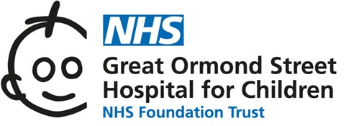
Department of Laboratory Medicine and Regional Genetics Service results portal

Outreach is a browser-based Portal for the review of laboratory reports stored in the Epic repository for samples referred to the GOSH laboratories.

The portal provides –
• An external, secure review of results by Health Care Providers (HCPs) or Submitting Location
• Secure access to allow HCPs to review their results or the results of their practice (multiple HCP practices) as part of registration and security set-up
• Email notifications to the user are generated at the point of report verification.

A Quick Start Guide for more information on how to use the system and browser compatibility will be sent out with your account, this also includes a user agreement to be returned.

Please complete the form below and return it to gos-tr.outreach@nhs.net. This request form should ideally be completed by the laboratory manager or equivalent of the establishment seeking access. A valid departmental NHS.net email account is required, as this will not only form the user login, but will be used as a primary mode of contact. Please supply all information requested below so that the system managers can identify your establishment and accurately configure your account.

Remote Access Request Form
Title
Name and Surname
Role
Email Address
Organisation Name
Department
Departmental
NHS.net Email Address
Address
Telephone Number
Can you confirm if you previously/currently have a GOSHLink account with us? | NO | Yes and my user name is:
Have you previously sent samples to GOSH? If yes, please provide us with the specimen number (21LM, 22LM, 22S..number)  Or RQ number | NO | Yes and here are a few 21LM or 22 LM or RQ number:
Signature & Date

