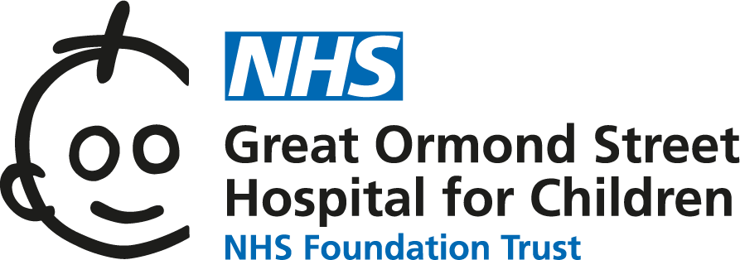

Catecholaminergic Polymorphic Ventricular Tachycardia (CPVT): information for families
Catecholaminergic Polymorphic Ventricular Tachycardia (CPVT) is a rare heart condition which affects the electrical system of the heart. This information sheet from Great Ormond Street Hospital (GOSH) explains the causes and symptoms of CPVT and how it can be treated.

The heart is a special kind of muscle which acts as a pump to keep blood moving around the body. There are four chambers; two smaller ones at the top called the left and right atrium, and two larger one on the bottom of the heart called the left and right ventricles.
The pumping action of the heart muscle is initiated by an electrical impulse which passes through the walls of the heart, causing them to contract. This electrical impulse starts in a specialised area of heart tissue in the right atrium called the sinoatrial (SA) node. It then passes from the right atrium through to the ventricles via the atrioventricular (AV) node.
As the impulse passes through the right atrium and left atrium, it makes these chambers contract and pump blood into the ventricles below. It has the same effect as the impulse passes through the ventricles. As the ventricles contract, blood is forced out of the heart.
Blood in the right side of the heart is forced to the lungs to pick up oxygen and blood in the left side of the heart travels to the body to deliver oxygen and nutrients. The electrical impulse inside the heart is something that happens naturally and it travels through the heart each time it beats.
The electrical impulse through the heart is created by the movement of sodium, potassium and calcium ions across the cells. Ions are small particles which carry a tiny electrical charge. These ions move in and out of the cells via ‘channels’ which are found in the walls of the heart muscle cells.
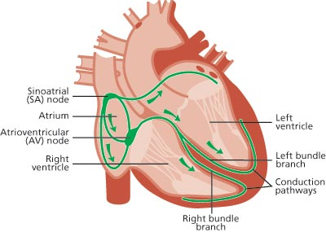

What is Catecholaminergic Polymorphic Ventricular Tachycardia (CPVT)?
CPVT is a rare heart condition which affects the electrical system of the heart. In particular, the level of calcium inside the heart cells is not regulated properly, which makes people with CPVT especially vulnerable to abnormal heart rhythms (or arrhythmias). Because of the way that adrenaline interacts with calcium in the heart, people with CPVT are most at risk of developing an arrhythmia when they experience a sudden rush of adrenaline. This might be in response to exercise or as a result of an emotional stimulus (like a sudden shock or an upsetting event).
The name CPVT stands for Catecholaminergic Polymorphic Ventricular Tachycardia. Although this is a very long and complicated sounding name, it is really just a description of what happens in this condition:
- Catecholaminergic - catecholamine is a hormone that is released into your body to produce adrenaline. It is this “adrenaline rush” that can trigger an arrhythmia in people with CPVT.
- Polymorphic – this describes the type of arrhythmia that can occur in CPVT. It means that the arrhythmia is occurring in lots of different areas of the ventricles of the heart.
- Ventricular tachycardia (also called VT) – this is an abnormal heart rhythm originating in the bottom chambers of the heart. It causes the ventricles to beat extremely fast meaning they cannot pump blood out of the heart effectively. This results in a drop in blood pressure, leading to dizziness, fainting and, potentially, a cardiac arrest.
Another arrhythmia you may hear about is:
- Ventricular fibrillation (also called VF) – this is when all the muscle cells in the ventricle are contracting independently in a disorganised way, effectively stopping the heart muscle from making a co-ordinated movement to contract. Instead of pumping, the heart is tremoring (fibrillating). This means blood is not being effectively pumped out of the heart to the lungs and body. This is known as a cardiac arrest.
Ventricular tachycardia and ventricular fibrillation can be very dangerous and if left untreated can result in sudden death.
It is important to note that not all people with CPVT will have these arrhythmias; however people with this condition do have an increased risk compared to other people in the population. Fortunately, there are treatments available to help manage the heart rhythm in people with CPVT – these are explained later.

What causes CPVT?
Genes are like instructions which tell our bodies how to grow and develop. They work by building proteins, which have a huge range of functions in different parts of the body. Some genes carry instructions for building the proteins involved in calcium transport and storage in the heart.
In people with CPVT, these genes have a change that prevents the proteins from developing or working properly. This results in the heart muscle cells of these people being unable to regulate calcium levels properly. Genetic changes like this are called “variants” or “mutations”. This means that they are changes from the normal genetic code that we would expect for that gene.
In some people, the genetic change that causes CPVT occurs in them for the first time. This is called a de novo change. These de novo genetic changes happen around the time of conception, and they are random—there is nothing we can do to cause or prevent them. In people with a de novo gene change, there is no family history of CPVT because they are they first person in the family to be affected.
In other people, the genetic change that causes CPVT has been inherited from one of their parents, which means that the condition first arose in an earlier generation of the family and has been passed down to them.
It is important that when a person is diagnosed with CPVT, their close family members are also screened and tested as some people may not be aware that they have the condition.

How is CPVT inherited?
Everyone inherits two copies of each of their genes, one copy from their mother and one from their father. This means that we all carry two copies of each gene. In some health conditions, only one copy of a gene has to be abnormal to cause signs of the disease to arise. This is called ‘autosomal dominant’ inheritance. In other conditions, both copies of a gene need to have changes in order for signs of the disease to occur. This is called “autosomal recessive” inheritance.
In the case of CPVT, it is possible for the condition to be inherited in either way; it just depends on which gene is affected.
Autosomal dominant
When a genetic condition is inherited in an autosomal dominant manner, a person only has to inherit the gene change from one parent to develop the condition. Each time an affected person has another child there is a 1 in 2 (50%) chance that the child will have the condition, regardless of the sex of the child.
Most cases of CPVT are caused by a change in a gene called RYR2. This gene carries the instructions for building the ryanodine calcium channel in heart cells. Changes in the RYR2 gene follow an autosomal dominant inheritance pattern.
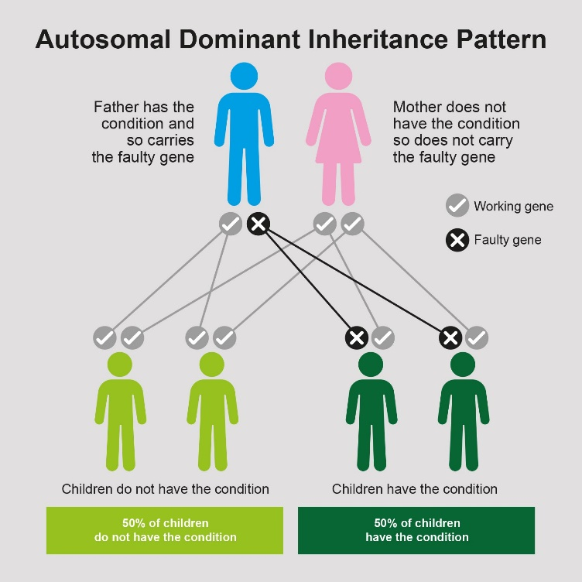
Autosomal recessive
When a genetic condition is inherited in an autosomal recessive manner, a person has to inherit abnormal copies of the gene from both of their parents in order to develop the condition. Each time a person carrying the gene change has another child, there is a 1 in 4 (25%) chance that the child will have the condition, regardless of the sex of the child.
Another gene known to cause CPVT is CASQ2. This gene carries instructions for building a protein called calsequestrin which is involved in binding to calcium inside the heart cells. Changes in CASQ2 follow autosomal recessive inheritance.
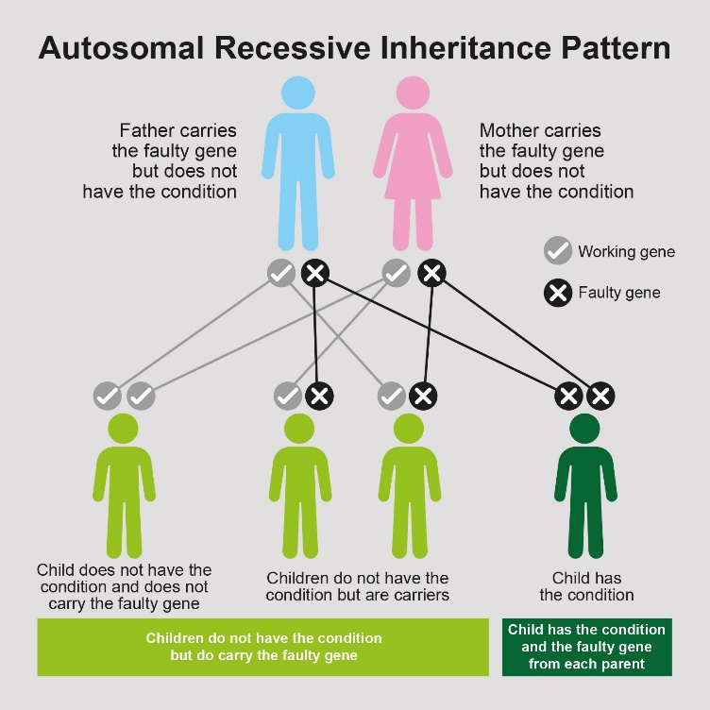

What are the symptoms of CPVT?
Many people with CPVT may never experience any symptoms during their lifetime. As they don’t show any symptoms the condition can remain undiagnosed for a long time. Other people with CPVT may experience symptoms such as palpitations, chest pain, dizziness, feeling lightheaded (pre syncope) or a sudden faint or blackout (syncope). The symptoms of CPVT can be well managed using medications. This is discussed in more detail further on in this booklet.
As mentioned above, people with CPVT are at an increased risk of developing abnormal heart rhythms, known as arrhythmias. These arrhythmias can be life threatening if left untreated. People with a diagnosis of CPVT should be seen regularly in a specialist inherited cardiovascular disease clinic, where the risk of abnormal arrhythmias can be properly assessed and managed.

How is CPVT syndrome diagnosed?
CPVT may be suspected if a person has an unexpected faint or blackout which is due to an abnormal heart rhythm. Unfortunately, for some people, the first time CPVT may be suspected is after a life-threatening event or sudden death in another family member, especially if there have been no symptoms beforehand. CPVT can also be diagnosed incidentally following a routine ECG for something else entirely.
If CPVT is suspected in your family, or if your child has had symptoms which could have been caused by CPVT, your GP or paediatrician (if your child has one) will refer your child to see a cardiologist with specialist knowledge of inherited cardiac conditions. The cardiologist will order a number of tests to clarify whether or not your child has CPVT.
CPVT can be diagnosed by seeing a particular type of arrhythmia on the patient’s ECG. Because this arrhythmia is often triggered by an adrenaline rush in people with CPVT, the most reliable diagnostic test for this condition is an exercise test, which stimulates the release of adrenaline in the patient:
- Exercise test – involves having an ECG undertaken during physical activity. Usually this is running on a treadmill, but sometimes it may be carried out while riding on a stationary bike.
Some other tests that the cardiologist may order include:
- Echocardiogram – this is an ultrasound scan of the heart and it is carried out to make sure that the structure of the heart is normal
- Electrocardiogram (ECG) – this test is used to measure the electrical activity of the heart, using sensors (stickers) that are stuck to the chest
- 24 hour ambulatory ECG monitor (sometimes called a Holter monitor) - this is similar to an ECG, except that the sensors are worn for 24 hours to monitor the electrical activity of the heart for a longer period of time
In some cases, where there is a family history of CPVT, genetic testing may be used to see if members of the family carry the gene change that can cause CPVT. To carry out genetic testing, a blood sample is collected and sent to a specialist laboratory for testing. It is important to be aware that this type of testing may not be available to all families. The testing process and the implications of the potential test results will always be discussed in detail with the patient and family before any genetic testing is undertaken.

How is CPVT treated?
Fortunately, there are treatments available to help manage the heart rhythm in people with CPVT – your clinical team will tell you more about these.
Medication
CPVT cannot be cured, but there are several options to manage the symptoms and protect against irregular heart rhythms. Most people with CPVT take a medication called a beta-blocker, which helps to regulate the heart rate and reduces the risk of arrhythmias developing. For some people with CPVT, beta-blockers alone are an effective treatment option, however many people with this condition also need to take an additional medication called flecainide, which works alongside their beta-blocker to help manage symptoms and reduce the risk of arrhythmias developing. Taken together, these medications can be very effective in managing CPVT for most people.
Implantable Cardioverter Defibrillator (ICD)
In a small number of cases, an individual with CPVT may continue to develop arrhythmias, despite taking medications. Other people with CPVT may have suffered a cardiac arrest previously. In both cases, these individuals are at a greater risk of developing a dangerous arrhythmia (and therefore have an increased risk of sudden death). For these people, an implantable cardioverter defibrillator (ICD) may be considered. An ICD is a small, surgically-implanted device that is able to monitor the heart rhythm continuously. If the ICD detects an arrhythmia it is able to treat this by delivering a burst of electrical energy to the heart, sometimes referred to as a “shock”. This therapy returns the heart back into a normal rhythm.
Left Cardiac Sympathetic Denervation
In some instances, medication alone may not be enough to reduce the risk of arrhythmias developing. As mentioned earlier, often the cause of arrhythmias in patients with CPVT is due to the adrenaline rush that a person can experience. One way to reduce the effect of an adrenaline rush is to carry out a procedure called a left cardiac sympathetic denervation (LCSD). This is also sometimes called a sympathectomy.
The heart rate is controlled by the central nervous system. When there is an adrenaline rush, this can trigger the nervous system to tell the heart to beat faster. This can sometimes cause arrhythmias to occur in people with CPVT. The left cardiac sympathetic denervation (LCSD) procedure involves cutting one of the nerves connected to the heart. This reduces the amount of arrhythmias that could occur. This procedure is only required in small number of patients with CPVT. If your cardiologist thinks this type of procedure is needed, more details can be given by the team in clinic.

Life with CPVT
As well as clinical treatment, people with CPVT also benefit from support such as the following:
Psychosocial support
Receiving a diagnosis of CPVT can be worrying for everyone involved, so we usually suggest that patients and their families receive some psychosocial support. This allows them to talk through their feelings and have some help coming to terms with their new diagnosis. Our clinical nurse specialists are available to help answer any questions you may have about CPVT and they can help explain the condition to children and young people.
Some of the symptoms that are described in CPVT, such as palpitations and chest pain, are very similar to the symptoms of anxiety. If a person with CPVT feels anxious about their condition, then they may experience symptoms caused by this anxiety. These can easily be misinterpreted as cardiac symptoms caused by the condition itself, and this can lead to further worry and further worsening of anxiety symptoms. The Inherited Cardiovascular Disease team at GOSH has a psychologist working within our team to help our patients develop coping strategies to overcome these difficulties.
In some cases, families are referred to our service for cardiac screening tests because they have lost a close family member due to CPVT. Our psychologists are also available to offer bereavement counselling for those who have lost someone close to them.
Lifestyle advice
Having CPVT will mean lifelong follow-up in the cardiology clinic to monitor the condition, to manage medication doses and to continually assess risk. During adolescence the Inherited Cardiovascular Disease team at GOSH offer young people the opportunity to attend our transition clinics. These clinics give them the chance to speak with the doctor alone and to talk to one of our clinical nurse specialists in more detail about their condition and life with CPVT. The transition clinics help to prepare young adults for their care being transferred to an adult hospital.
Having CPVT may mean that some careers are unsuitable for your child – for instance, the armed forces or professional sports. You can ask the team about this at any time, but it can also be discussed with young people in more detail during the transition clinics.
Day-to-day management of CPVT involves identifying the triggers for symptoms and avoiding them wherever possible. It is also important to treat any prolonged period of diarrhoea and vomiting as this can cause dehydration and the loss of potassium and sodium, which can increase the risk of arrhythmias. Re-hydration sachets contain a good balance of minerals as well as fluid to replace any losses. If this period of sickness continues, seek medical advice.
We recommend that all children and young people with CPVT wear a medical identity bracelet or necklace to highlight their diagnosis and medical needs in case of emergency. There are lots of different types and styles available – ask for details at the Patient Advice and Liaison Service (PALS) office in the main reception area at GOSH.
Exercise
As high intensity exercise and strenuous activity can trigger arrhythmias in CPVT, we advise that highly competitive or prolonged vigorous exercise should be avoided. However, maintaining a healthy and balanced lifestyle is equally important for good general health. We would encourage children and young people with CPVT to participate in PE, swimming, recreation and games alongside their peers. It is important that they continue to take the medication that has been prescribed and that they attend the cardiology clinic regularly for close monitoring. Each time they attend clinic, the cardiologist will ensure that their medication doses are correct and working well.
If you have specific questions relating to exercise and CPVT for your child, you can speak with your cardiologist or one of the clinical nurse specialists for further advice.

Further information and support
Contact the Centre for Inherited Cardiovascular Diseases on 020 7829 8839 (team secretary) or Clinical Nurse Specialists for Inherited Arrhythmia on 020 7405 9200 extension 5139. You can also email them on icvd@gosh.nhs.uk or contact them via MyGOSH once you’ve registered – more information is available at www.gosh.nhs.uk/your-hospital-visit/mygosh. Further information about the ICVD team is at www.gosh.nhs.uk/medical-information/clinical-specialties/inherited-cardiovascular-diseases-information-parents-and-visitors
The following support organisations may also be able to help:
- The Arrhythmia Alliance supports anyone affected by a heart rhythm problem. Call their 24 hour helpline on 01789 867 501 or visit their website at www.heartrhythmcharity.org.uk
- CRY (Cardiac Risk in the Young) is another organisation offering advice and support to families of children with heart problems. Call them on 01737 363 222 or visit their website at www.c-r-y.org.uk
- SADS UK offers support and advice about heart conditions that can lead to sudden unexpected death. Telephone them on 01277 811 215 or visit their website at www.sadsuk.org
- The British Heart Foundation is the main organisation in the UK offering advice and support to anyone affected by heart disease. Call their Heart Helpline on 0300 330 3311 or visit their website at www.bhf.org.uk

