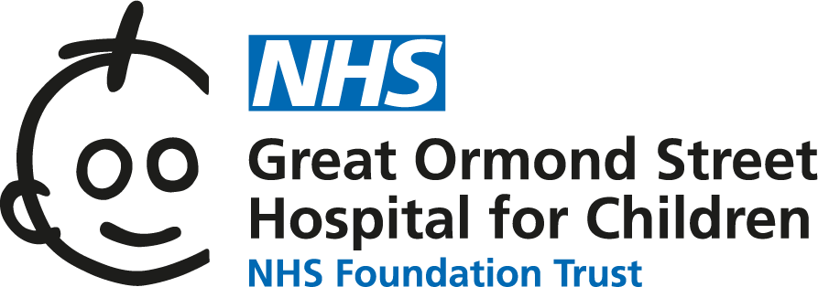

Long QT syndrome: information for families
In people with Long QT syndrome the structure and function of the heart is normal but the electrical system is affected. This information sheet from Great Ormond Street Hospital (GOSH) explains the causes and symptoms of Long QT syndrome and how it can be treated.

The heart is a special kind of muscle which acts as a pump to keep blood moving around the body. The pumping action of the heart muscle is initiated by an electrical impulse which passes through the walls of the heart, causing them to contract. This electrical impulse starts in a specialised area of heart tissue in the right atrium called the sinoatrial (SA) node. It then passes from the right atrium through to the ventricles via the atrioventricular (AV) node.
As the impulse passes through the right atrium and left atrium, it makes these chambers contract and pump blood into the ventricles below. It has the same effect as the impulse passes through the ventricles. As the ventricles contract, blood is forced out of the heart. Blood in the right side of the heart is forced to the lungs to pick up oxygen and blood in the left side of the heart travels to the body to deliver oxygen and nutrients. The electrical impulse inside the heart is something that happens naturally and it travels through the heart each time it beats.
The electrical impulse through the heart is created by the movement of sodium, potassium and calcium ions across the cells. Ions are small particles that carry a tiny electrical charge. These ions move in and out of the cells via ‘channels’ which are found in the walls of the heart muscle cells.
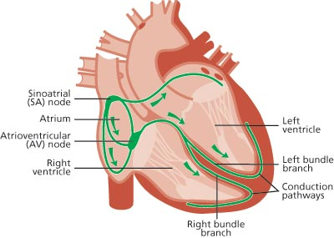

What is Long QT syndrome?
In Long QT syndrome, there are abnormalities in the proteins that make the ion channels. This can alter the flow of ions into and out of the heart muscle cells, causing the heart to take longer to reset itself electrically between each beat.
The name ‘long QT’ describes the tracing pattern that is seen on the ECG. At each point on the ECG there are different waves, and each of these waves are given names. There is the P-wave, the QRS wave and the T-wave. Long QT is describing the measurement between the start of the Q wave and the end of the T wave. Measuring between these two waves gives us an indication of how long it takes the heart to ‘reset’ itself after each heartbeat. This process of resetting is called “repolarisation”. With someone with Long QT syndrome the measurement (measured in milliseconds) between the Q wave and T wave is prolonged.
Due to this prolonged repolarisation, people with Long QT syndrome are at an increased risk of developing an arrhythmia (abnormal heart rhythm). Two abnormal heart rhythms may be discussed with you:
- Ventricular tachycardia (VT) – this is an abnormal rhythm that can cause the heart to beat extremely fast, meaning it does not have time to fill with blood between each beat. This makes it hard for the heart to pump blood to the body, which can cause a drop in blood pressure causing a faint, or can lead to a cardiac arrest.
- Ventricular fibrillation (VF) – this is when all the heart muscles cells are firing at the same time meaning the heart is not able to make a co-ordinated movement to contract and pump blood out of the heart to rest of the body. This is known as a cardiac arrest.
Both of these types of rhythm can be very dangerous and if left untreated can cause sudden death. Fortunately, there are treatments to help manage these rhythms explained below.

What causes Long QT syndrome?
Long QT syndrome can be present at birth (congenital) or can be acquired at any age in response to certain medications.
The congenital form is caused by a faulty gene. This faulty gene leads to an abnormality in the proteins making up the ion channels within the walls of the heart muscle cells. This, in turn, affects the movement of potassium and sodium molecules into and out of the cells, which disturbs the electrical system within the heart.
Long QT syndrome is passed on in an autosomal dominant manner. This means a person only has to inherit the faulty gene from one of their parents to develop the condition. Each time a person with Long QT syndrome has a child, there is a 1 in 2 (or 50 per cent) chance that the child will have the condition.
It is therefore important that, if one person in a family is diagnosed with Long QT syndrome, other close relatives should be tested as well.
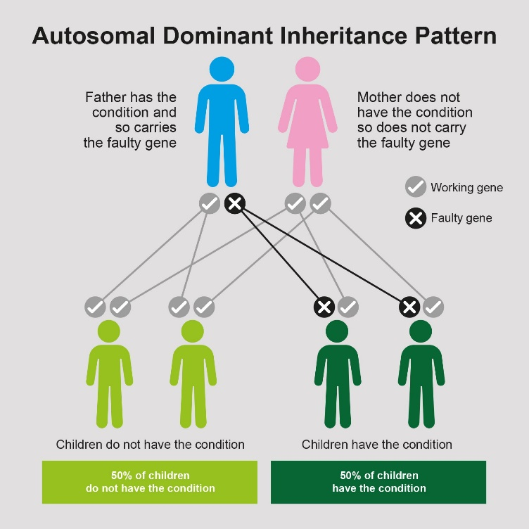
Occasionally, the faulty gene can develop sporadically (out of the blue) without being passed on from a parent. In this case, the faulty gene can still be passed on when the affected person has children of their own.
There are a number of different types of Long QT syndrome. The three most common types listed below have slightly different triggers that can cause abnormal rhythms in affected individuals:
- Type 1 (LQT1) – symptoms tend to be triggered by exercise
- Type 2 (LQT2) – symptoms tend to be triggered by stress or sudden or unexpected sounds
- Type 3 (LQT3) – symptoms tend to occur while resting or asleep
It can be difficult to diagnose the type of Long QT syndrome that someone has without carrying out genetic testing, however sometimes an experienced cardiologist may be able to tell from the clinical history and from looking at the ECG.

What are the symptoms of Long QT syndrome?
Some people do not show any symptoms so the condition can remain undiagnosed for a long time. Many people with Long QT syndrome will never experience any symptoms during their lifetime. Some may experience palpitations, dizziness, feeling lightheaded (pre syncope) or a sudden faint or black out (syncope).
As mentioned before, Long QT syndrome can put affected individuals at an increased risk of developing abnormal heart rhythms, known as “arrhythmias”. Some of these arrhythmias are dangerous and can be life threatening if left untreated, potentially causing sudden death.
Symptoms can be controlled with medications and any risk of arrhythmias can be properly assessed and managed by appropriate follow-up with a specialist inherited cardiovascular disease service. Treatments for Long QT syndrome are discussed elsewhere in this leaflet.

How is Long QT syndrome diagnosed in people with no symptoms?
Long QT syndrome may be suspected if a close relative has an unexpected faint or black out due to developing an abnormal heart rhythm. Unfortunately, for some people and families, the first time Long QT syndrome may be suspected is when a life-threatening event or sudden death occurs in the family. The condition may also be diagnosed incidentally following a routine ECG for something else entirely.

What happens next when Long QT syndrome is suspected?
If Long QT syndrome is suspected due to either a family history or symptoms, your GP or local hospital will refer you to see a cardiologist with specialist knowledge of inherited cardiac conditions. The cardiologist will order a number of tests to help diagnose Long QT syndrome:
- Echocardiogram – this is an ultrasound scan of the heart, to make sure the structure of the heart is normal
- Electrocardiogram (ECG) – this measures the electrical activity of the heart, using sensors (stickers) that are stuck to the chest
- 24 hour Holter - this is similar to an ECG, except that the sensors are worn for 24 hours to monitor the electrical activity of the heart for a longer period of time
- Exercise test – looks at the electrical activity of the heart at peak physical exertion
In some cases, where there is a family history of Long QT syndrome, genetic testing may be used to see if members of a family carry the same faulty gene that can cause Long QT syndrome. To carry out genetic testing, a blood sample is collected and sent to a specialist laboratory for testing. It is important to note that this type of testing may not be available to all families. The cardiologist and the genetic counsellor will be discuss this in detail with the patient and their family before any genetic testing is undertaken.

How is Long QT syndrome treated?
Fortunately, there are treatments available to help manage the heart rhythm in people with Long QT syndrome – your clinical team will tell you more about these.
Medication
Long QT syndrome cannot be cured, but there are several options to manage the symptoms of fainting and irregular heart rhythms. Most people take a medication called a beta-blocker, which helps to regulate the heart rate and reduces the risk of developing arrhythmias. Beta-blockers are a very effective treatment for people with Long QT syndrome and in the majority of circumstances this medication is enough to manage the condition and the symptoms associated with it.
It is important to note that there are some medications that can prolong the QT interval. It is important that if you have a diagnosis of Long QT syndrome, or if there is any suspicion of Long QT syndrome, these medications should be avoided. A regularly updated list of the medications to be avoided can be found on: www.crediblemeds.org. It is wise to always check with the pharmacist before taking any medicines, including those prescribed or bought over the counter as well as herbal and complementary medicines. If a medication is on the list, a suitable alternative can be found in nearly all circumstances.
Implantable Cardioverter Defibrillator (ICD)
In a small number of cases, an individual with Long QT syndrome may continue to have symptoms or develop arrhythmias despite taking beta-blocker medication. In cases where an individual is at a greater risk of developing a dangerous arrhythmia (and therefore at increased risk of sudden death) an ICD may be considered. An ICD is a small device which is inserted under the skin and monitors the heart rhythm continuously. If the ICD detects an abnormal heart rhythm it is able to treat this by delivering a burst of energy to the heart, called a shock. This reverts the heart back into a normal rhythm. Further information of these devices is available from the Inherited Cardiovascular Diseases team and on the Great Ormond Street Hospital website.
The heart rate is controlled by the central nervous system. When there is an adrenaline rush (often caused by emotional triggers such as anxiety or excitement), this triggers the nervous system to tell the heart to beat faster. In people with certain types of Long QT syndrome, this can sometimes cause arrhythmias to occur. One way to reduce the effect of the adrenaline rush (therefore limiting the risk of further arrhythmias) is to carry out a procedure called a left cardiac sympathetic denervation (LCSD). This is also sometimes called a sympathectomy.
The left cardiac sympathetic denervation (LCSD) procedure involves cutting one of the nerves connected to the heart. This reduces the amount of arrhythmias that could occur. This procedure is only effective with certain types of Long QT syndrome, and only a small number of patients with this type of Long QT syndrome would require a LCSD. If your cardiologist thinks this is something that would be needed, more details can be given by the team in clinic.

Life with Long QT syndrome
As well as clinical treatment, people with Long QT syndrome also benefit from support such as the following:
Psychosocial support
Receiving a diagnosis of Long QT syndrome can be worrying for everyone involved, so we usually suggest having some psychosocial support to talk through feelings and coming to terms with the new diagnosis. Our clinical nurse specialists are available to help answer any questions you may have about Long QT syndrome as well as to help explain the condition to children and young people.
Many of the symptoms associated with Long QT syndrome are very similar to symptoms that are caused by anxiety. Symptoms such as palpitations or chest pain can occur as a result of anxiety, but may be interpreted as symptoms of Long QT syndrome. This can create further anxiety, which leads to a vicious circle of worry and further symptoms. The Inherited Cardiovascular Disease (ICVD) team at GOSH has a psychologist working within our team to help our patients develop coping strategies to overcome this problem.
In some cases, families are referred to our service for cardiac screening because they have lost a close relative due to Long QT syndrome. Our psychologists can offer bereavement counselling for patients and families who have been affected by the death of someone close to them.
Lifestyle advice
Having Long QT syndrome will mean lifelong follow-up to monitor the condition, manage medication doses and continually assess arrhythmia risk. During adolescence the, ICVD team at GOSH offer young people the opportunity to attend our transition clinics. This gives them the chance to speak with the doctor and one of our clinical nurse specialists in more detail about their condition and life with Long QT syndrome. It also helps them to prepare for when their care is transferred to an adult hospital. Having Long QT syndrome may mean that some careers are unsuitable for your child – for instance, the armed forces and professional sports. You can ask the team about this at any time, but it can also be discussed with young people in more detail during the transition clinics.
Day-to-day management of Long QT syndrome involves identifying the triggers for symptoms and avoiding them where possible.
It is also important to treat any prolonged period of diarrhoea and vomiting as this can cause dehydration and the loss of potassium and sodium. Re-hydration sachets contain a good balance of minerals as well as fluid to replace any losses. If this period of sickness continues, seek medical advice.
We recommend that all children and young people with Long QT syndrome wear a medical identity bracelet or necklace to highlight their diagnosis and medical needs in case of emergency. There are lots of different types and styles available – ask for details at the Patients Advice and Liaison Service (PALS) office in the main reception area at GOSH.
Exercise
For some types of Long QT syndrome, high intensity exercise and strenuous activity can trigger arrhythmias. We advise that highly competitive/strenuous activities or prolonged vigorous exercise should be avoided. However, maintaining a healthy and balanced lifestyle is equally important for good general health. We would encourage children and young people with Long QT syndrome to participate in PE, swimming, recreation and games. It is important that they continue to take medications that have been prescribed and attend clinic regularly for close monitoring to ensure that the doses of medications are correct and working well.
If you have specific questions relating to exercise and Long QT syndrome for your child, you can speak with your cardiologist or one of the clinical nurse specialists for further advice.

Further information and support
Contact the Centre for Inherited Cardiovascular Diseases on 020 7829 8839 (team secretary) or Clinical Nurse Specialists for Inherited Arrhythmia on 020 7405 9200 extension 5139. You can also email them on icvd@gosh.nhs.uk or contact them via MyGOSH once you’ve registered – more information is available at www.gosh.nhs.uk/your-hospital-visit/mygosh. Further information about the ICVD team is at www.gosh.nhs.uk/medical-information/clinical-specialties/inherited-cardiovascular-diseases-information-parents-and-visitors
The following support organisations may also be able to help:
- The Arrhythmia Alliance supports anyone affected by a heart rhythm problem. Call their 24 hour helpline on 01789 867 501 or visit their website at www.heartrhythmcharity.org.uk
- CRY (Cardiac Risk in the Young) is another organisation offering advice and support to families of children with heart problems. Call them on 01737 363 222 or visit their website at www.c-r-y.org.uk
- SADS UK offers support and advice about heart conditions that can lead to sudden unexpected death. Telephone them on 01277 811 215 or visit their website at www.sadsuk.org
- The British Heart Foundation is the main organisation in the UK offering advice and support to anyone affected by heart disease. Call their Heart Helpline on 0300 330 3311 or visit their website at www.bhf.org.uk

