

**Data about our staff: For publication January 2015**

# Introduction

**The Trust’s position**

We can only provide the highest quality healthcare to children and their families if we recruit the best possible staff, and if all these staff are treated with respect and are valued. The Trust is currently in the process of embedding Our Always Values, a set of shared values and behaviours which characterise all our dealings with each other. We also have policies and procedures that help us to ensure rights and responsibilities are applied equitably, and we have processes that allow us to examine problems fairly and sensitively when they arise. We collect data and review what we do to help ensure that we are not inadvertently behaving in a way that disadvantages some people. Our aim is for equality and diversity issues to become mainstreamed across all that we do and that we take action to ensure that we:

* **Eliminate unlawful discrimination, harassment and victimisation and other conduct prohibited by the Equality Act.**
* **Advance equality of opportunity between people who share a protected characteristic and those who do not.**
* **Foster good relations between people who share a protected characteristic and those who do not.**

**The law**

The Equality Act (2010) introduced a specific statutory duty (the Equality Duty) in April 2011 which is applicable to all public sector bodies. It requires that public sector bodies develop and work towards equality objectives. The Trust utilised the NHS Equality Delivery System (EDS) to develop our objectives. The objectives were ratified by Trust Board in 2012 and a copy of these objectives and the progress made against them as at Jan 2015 is posted on our website ([www.gosh.nhs.uk](http://www.gosh.nhs.uk)).

**This report**

As a public sector body we must demonstrate compliance with the Equality Act and Duty. We can demonstrate this through the work we do, the involvement we have of the Trust Board in this work, and through publishing a range of equalities data on an annual basis. This report contains equality information relating to staff and should be read in conjunction with that regarding service users, a copy of which is also available on the GOSH website. Unless specified otherwise, all data contained within this report covers the period 01 Dec 2013 – 30 Nov 2014 (for simplicity this data has been titled 2014 data).

# Workforce Demographic and Pay Information by Protected Characteristic

## Nb Percentages in all tables have been rounded up or down and so may not always add up to 100.

# Race

Table 1 – Comparison of race/ethnicity of GOSH staff

|  |  |  |  |  |  |
| --- | --- | --- | --- | --- | --- |
| **Ethnic Group** | **2014** | **2013** | **2012** | **2011** | **2010** |
| White | 73% | 73% | 73% | 72% | 71% |
| BME | 27% | 27% | 27% | 28% | 29% |
| Not known | 0% | 0% | 0% | 0% | 0% |

Table 2 – Breakdown of ethnic origin of GOSH staff

|  |  |  |  |  |  |
| --- | --- | --- | --- | --- | --- |
| Ethnic Group | **2014** | **2013** | **2012** | **2011** | **2010** |
| Asian | 12% | 12% | 11% | 12% | 12% |
| Black | 9% | 9% | 9% | 10% | 11% |
| White | 73% | 73% | 73% | 72% | 71% |
| Other (inc Mixed) | 6% | 6% | 6% | 6% | 6% |
| Not known | 0% | 0% | 0% | 0 % | 0% |

The 2011 census showed that 86% of the UK population is White British. Within Inner London this decreases to 57% of the population and in Camden, the proportion of White British is 66%. Within London the proportion of White British people has decreased over recent years, whilst at GOSH the proportion of employed White British staff has remained static across the last three years. This may be a reflection of the fact that significant numbers of jobs at GOSH, being specialist in nature, are not recruited from the local population rather GOSH recruits from regional and national and even international job markets.

Table 3 – Staff group by ethnic origin

|  |  |  |  |  |  |  |
| --- | --- | --- | --- | --- | --- | --- |
|  | **White** | | **BME** | | **Unknown** | |
| **STAFF GROUP** | **2014** | **2013** | **2014** | **2013** | **2014** | **2013** |
| Whole Trust | 73% | 73% | 27% | 27% | 0% | 0% |
| Administrative and Clerical | 65% | 67% | 35% | 32% | 0% | 0% |
| Allied Health professionals | 89% | 88% | 11% | 12% | 0% | 0% |
| Estates, ancillary and unqualified clinical support | 58% | 60% | 42% | 40% | 0% | 0% |
| Medical and dental | 67% | 67% | 33% | 33% | 0% | 0% |
| Nursing and midwifery registered | 85% | 84% | 15% | 16% | 0% | 0% |
| Scientific and technical | 70% | 71% | 30% | 29% | 0% | 0% |

The trends noted in last year’s report have continued in that BME staff continue to be very significantly disproportionately underrepresented in Nursing and Allied Health professionals. GOSH has continued to hold well attended nursing job fairs during 2014, aimed at attracting newly qualified nursing staff from across the country to work for us. The Trust also continues its close working relationship with Southbank University which is responsible for providing paediatric nursing students to the wards, in order to ensure that diversity is maximised at professional entry level. Following the success of recruiting nurses abroad for Intensive care, during 2014 the Trust undertook four nurse recruitment campaigns in Ireland to help staff a range of specialities across the hospital. During 2015 there are plans to extend our relationship with two of the international recruitment agencies to include other areas within Europe.

Table 4 – Pay band by ethnic origin

|  |  |  |  |
| --- | --- | --- | --- |
| Pay Band | **White** | **BME** | **Not disclosed** |
| Band 2 | 44% | 56% | 0% |
| Band 3 | 58% | 42% | 0% |
| Band 4 | 60% | 40% | 0% |
| Band 5 | 81% | 19% | 0% |
| Band 6 | 73% | 27% | 0% |
| Band 7 | 83% | 17% | 0% |
| Band 8a | 85% | 15% | 1% |
| Band 8b | 88% | 12% | 1% |
| Band 8c | 93% | 7% | 0% |
| Band 8d | 95% | 5% | 0% |
| Band 9 | 100% | 0% | 0% |
| Local manager pay scale (inc Directors) | 90% | 10% | 0% |
| Local non-manager pay scale | 84% | 16% | 19% (n=1) |
| M&D Career grade | 21% | 79% | 0% |
| M&D Consultant | 75% | 25% | 0% |
| M&D Junior | 61% | 39% | 0% |

Table 5 – Salary by ethnic origin

|  |  |  |  |  |  |  |
| --- | --- | --- | --- | --- | --- | --- |
| **Salary** | **White** | | **BME** | | **Unknown** | |
|  | 2014 | 2013 | 2014 | 2013 | 2014 | 2013 |
| <£25,000 p.a. | 68% | 68% | 32% | 32% | 0% | 0% |
| >£40,000 p.a. | 77% | 70% | 23% | 20% | 0% | 0% |

Following the trend of previous years, a disproportionate number of staff from BME groups continue to be over-represented in lower Agenda for Change pay bands and consequently earn lower salaries. The pay gap between white and BME staff within the Trust has been calculated at 11.63% compared to last year at 12.71% (note: current national data was not available at the time of publication for benchmarking). These findings are likely to be indicative of the disproportionate numbers of BME staff who hold ‘non-professional’ jobs which attract a lower salary.

In addition to the information gained through analysis of the data, the 2013 staff survey (data for the 2014 survey is not available at time of going to publication) showed that proportionally fewer BME staff than their white counterparts believe there are good opportunities for career progression or promotion, report less job satisfaction and are less engaged. However staff across all groups, report an increase in having had training in equality and diversity issues.

The Trust continues to support the GROW network. This network aims to develop and support BME staff in order to ensure they feel more confident and are equipped to apply for, and be appointed to, more senior roles. GROW offer keynote speakers to update staff on issues of interest and will continue look to create a network of mentors as well as facilitating shadowing opportunities for BME staff. Through the GROW network BME staff also have access to a range of courses and support to help develop their application and interview skills. In addition two of the Trust’s Equality and Diversity objectives are focused on promoting equity in recruitment and appraisal processes. These are additional to our other actions intending to prevent unfair discrimination in recruitment and are overseen by the Trust’s Staff Equality and Diversity Group.

# Age

Table 6 – GOSH staff by age

|  |  |  |
| --- | --- | --- |
| **Age Range** | **% of total FTE workforce 2014** | **% of total FTE workforce 2013** |
| 16 to 29 | 25% | 29% |
| 30 to 49 | 59% | 55% |
| 50 to 59 | 12% | 13% |
| 60+ | 3% | 3% |

Table 7 – Staff groups by age

|  |  |  |  |  |  |  |  |  |
| --- | --- | --- | --- | --- | --- | --- | --- | --- |
|  | **16 to 29** | | **30 to 49** | | **50 to 59** | | **60+** | |
| Staff Group | **2014** | **2013** | **2014** | **2013** | **2014** | **2013** | **2014** | **2013** |
| Administrative and Clerical | 27% | 27% | 51% | 51% | 17% | 17% | 4% | 5% |
| Allied Health professionals | 23% | 24% | 63% | 63% | 10% | 10% | 4% | 2% |
| Estates, ancillary & unqualified clinical support | 37% | 37% | 45% | 43% | 15% | 16% | 3% | 4% |
| Medical and dental | 4% | 5% | 77% | 76% | 14% | 15% | 4% | 4% |
| Nursing/midwifery registered | 45% | 42% | 46% | 49% | 7% | 8% | 1% | 1% |
| Scientific and technical | 22% | 20% | 61% | 63% | 14% | 14% | 3% | 3% |
| Total | 31% | 29% | 54% | 55% | 12% | 13% | 3% | 3% |

Table 8 –Pay band by age

|  |  |  |  |  |
| --- | --- | --- | --- | --- |
| Pay Band | **16 to 29** | **30 to 49** | **50 to 59** | **60+** |
| Band 2 | 20% | 45% | 26% | 9% |
| Band 3 | 48% | 38% | 12% | 2% |
| Band 4 | 37% | 44% | 14% | 4% |
| Band 5 | 66% | 28% | 5% | 1% |
| Band 6 | 28% | 60% | 10% | 2% |
| Band 7 | 12% | 77% | 9% | 2% |
| Band 8a | 5% | 71% | 22% | 2% |
| Band 8b | 0% | 58% | 38% | 3% |
| Band 8c | 0% | 56% | 37% | 7% |
| Band 8d | 3% | 46% | 39% | 13% |
| Band 9 | 0% | 75% | 25% | 0% |
| Local manager | 0% | 38% | 46% | 17% |
| Local non-manager | 33% | 49% | 0% | 18% |
| M&D Career grade | 0% | 45% | 41% | 14% |
| M&D Consultant | 0% | 65% | 28% | 8% |
| M&D Junior | 9% | 91% | 1% | 0% |

Table 9 - Salary by age

|  |  |  |  |  |  |  |  |  |
| --- | --- | --- | --- | --- | --- | --- | --- | --- |
|  | **16-29** | | **30-49** | | **50-59** | | **60+** | |
| **2014** | **2013** | **2014** | **2013** | **2014** | **2013** | **2014** | **2013** |
| <£25,000 | 55% | 53% | 33% | 34% | 10% | 10% | 2% | 3% |
| >£40,000 | 1% | 1% | 72% | 71% | 23% | 24% | 5% | 5% |

Table 9 shows that the percentage of staff in particular earnings categories according to their age has changed only marginally during 2014.

The data shows that the Trust continues to employ relatively young staff, with the majority of staff falling into the 30-49 age bracket. The Trust is keen to support the retention of older workers and provides advice and policies to support this. However we do anecdotally know that as staff become older and some decide to raise a family, they may move away from London and work within the community or with locally-based hospitals. The Trust offers a range of initiatives to try and retain such staff including a comprehensive flexible working policy open to all staff regardless of caring responsibilities, a staff hotel to support staff travelling long distances to work and an on-site subsidised staff nursery, holiday play schemes and salary sacrifice childcare vouchers.

# Gender

Breakdown:

The current proportion of male to female staff is 77%:23 %.

The promotion of NHS careers to both genders is aimed at addressing this imbalance, although societal drivers with regard to gender-related career choices are clearly influencing this picture.

Table 10 – Staff group by gender

|  |  |  |  |  |  |  |
| --- | --- | --- | --- | --- | --- | --- |
|  | **Female** | | **Male** | | **Unknown** | |
| **STAFF GROUP** | **2014** | **2013** | **2014** | **2013** | **2014** | **2013** |
| Whole Trust | 77% | 77% | 23% | 23% | 0% | 0% |
| Administrative and Clerical | 70% | 70% | 30% | 30% | 0% | 0% |
| Allied Health professionals | 92% | 93% | 8% | 7% | 0% | 0% |
| Estates, ancillary and unqualified clinical support | 71% | 70% | 29% | 30% | 0% | 0% |
| Medical and dental | 51% | 50% | 49% | 50% | 0% | 0% |
| Nursing and midwifery registered | 94% | 94% | 6% | 6% | 0% | 0% |
| Scientific and technical | 73% | 74% | 27% | 26% | 0% | 0% |

Table 11 – Pay band by gender

|  |  |  |
| --- | --- | --- |
| Pay Band | **Female** | **Male** |
| Band 2 | 61% | 39% |
| Band 3 | 79% | 21% |
| Band 4 | 77% | 23% |
| Band 5 | 86% | 14% |
| Band 6 | 86% | 14% |
| Band 7 | 84% | 16% |
| Band 8a | 71% | 29% |
| Band 8b | 82% | 18% |
| Band 8c | 78% | 22% |
| Band 8d | 64% | 36% |
| Band 9 | 75% | 25% |
| Local manager | 49% | 51% |
| Local non-manager | 78% | 22% |
| M&D Career grade | 66% | 34% |
| M&D Consultant | 45% | 55% |
| M&D Junior | 56% | 44% |

Table 12 - Gender by salary

|  |  |  |  |  |
| --- | --- | --- | --- | --- |
| **Salary** | **Female** | | **Male** | |
|  | **2014** | **2013** | **2014** | **2013** |
| <£25,000 p.a. | 80% | 80% | 20% | 20% |
| >£40,000 p.a. | 62% | 63% | 38% | 37% |

Table 13 – The Gender Pay Gap

|  |  |  |  |
| --- | --- | --- | --- |
|  | **2014** | **2013** | **2012** |
| Trust total | 11.63% | 12.04% | 7.33% |

The calculation used = (Median of male hourly pay - Median of female hourly pay) / (Median of male hourly pay) - based on pensionable pay (inclusive of pay elements such as basic, London weighting, enhancements, Clinical Excellence Awards but excludes overtime, expenses and APAs). This calculation is used by the EU to determine the gender pay gap.

In the UK the Pay gap is at its lowest point in history to 9.4% compared to 10% in 2013 (Office for National Statistics 2014). At GOSH the gap has reduced over the last year to 11.63% for all employees.

**Clinical Excellence Awards**

In common with all NHS employers of doctors, GOSH is required to consider each year whether its staff are eligible for clinical excellence awards. The process for making the awards is made by a panel comprising of staff from a range of ethnic groups which has had diversity training and the results are reported to the Department of Health for monitoring.

Table 14 – Breakdown of clinical excellence awards

The awards for this year have not been made at the time of publication. The Trust received 65 applicants with a 29:36 female: male split. Further work may be required to ensure that all consultant staff are clear about the criteria for CEAs and that some are not failing to put themselves forward. This may anecdotally particularly apply to female consultants.

# Disability

Table 15 – Breakdown of GOSH staff by disability

|  |  |  |
| --- | --- | --- |
| **Disability** | 2014 | 2013 |
| Yes | 2% | 1% |
| No | 72% | 69% |
| Undefined / not declared | 26% | 30% |

This data is collected at recruitment, applicants are given the choice of not declaring this information and they are not asked again (although it may be provided at a later stage by the Occupational Health Department for the management of individual employee health cases). The figures have remained fairly static over recent years, although there is a significant number who do not wish to declare whether they have a disability as many prefer not to be defined in this way.

Table 16 – Staff group by disability

|  |  |  |  |
| --- | --- | --- | --- |
|  | **Non-disabled** | **Disabled** | **Unknown / undeclared** |
| **STAFF GROUP** | **2014** | **2014** | **2014** |
| Whole Trust | 72% | 2% | 26% |
| Administrative and Clerical | 72% | 2% | 26% |
| Allied Health professionals | 70% | 2% | 29% |
| Estates, ancillary and unqualified clinical support | 78% | 2% | 20% |
| Medical and dental | 74% | 0% | 26% |
| Nursing and midwifery registered | 71% | 2% | 27% |
| Scientific and technical | 70% | 2% | 28% |

Table 17 – Pay band by disability

|  |  |  |  |
| --- | --- | --- | --- |
| Pay Band | **Disabled** | **Non-disabled** | **Unknown/ undeclared** |
| Band 2 | 2% | 67% | 30% |
| Band 3 | 3% | 85% | 13% |
| Band 4 | 2% | 73% | 26% |
| Band 5 | 3% | 87% | 10% |
| Band 6 | 2% | 66% | 32% |
| Band 7 | 1% | 59% | 41% |
| Band 8a | 1% | 59% | 40% |
| Band 8b | 2% | 56% | 41% |
| Band 8c | 0% | 42% | 58% |
| Band 8d | 1% | 59% | 40% |
| Band 9 | 0% | 50% | 50% |
| Local manager | 9% | 75% | 17% |
| Local non-manager | 0% | 82% | 18% |
| M&D Career grade | 0% | 25% | 75% |
| M&D Consultant | 0% | 49% | 51% |
| M&D Junior | 1% | 99% | 0% |

Table 18 – Salary by disability

|  |  |  |  |  |  |  |
| --- | --- | --- | --- | --- | --- | --- |
| **Salary** | **Disabled** | | **Non-disabled** | | **Unknown/undeclared** | |
|  | 2014 | 2013 | 2014 | 2013 | 2014 | 2013 |
| <£25,000 p.a. | 3% | 2% | 84% | 82% | 14% | 16% |
| >£40,000 p.a. | 1% | 0% | 58% | 55% | 41% | 44% |

The data shows that 3% of the workforce have a disability. However it is likely that the percentage of people with disabilities employed by GOSH is higher as many people do not wish to disclose this information or do not classify themselves as having a disability (even if they would fall under the legal definition of having a disability). The Trust has strategies in place to ensure that disabled people access and remain within employment. As well as being a Positive About Disabled People symbol user. The Trust has a redeployment process in place to ensure staff are retained in the organisation, and also has access to an in-house Occupational Health Service who are able to support staff with disabilities and provide advice as to any adjustments which they may require. The Trust also has an Employee Assistance Program provided by a leading supplier which supports both staff and managers through the provision of advice, information, support and counselling interventions. This support is available to all but we will continue to work closely with staff experiencing health difficulties, including those with disabilities, to ensure that they receive the support they require.

# Pregnancy and Maternity

As we have already seen the Trust employs many more females than males and has a relatively young workforce. Consequently, the effect of maternity leave can present significant workforce challenges, especially if it is concentrated in one or two clinical areas. A snapshot of those on maternity/adoption leave as of November 2014 found that 3.71% of the workforce were on maternity/adoption leave at this time. Again the Trust has measures in place to help support those on maternity leave to return to employment and these include flexible working initiatives, subsidised on-site staff nursery and the provision of childcare vouchers.

# Marriage & Civil Partnership

A snap shot as of November 2014 has also been obtained which shows the breakdown of the workforce against their declared marital/civil partnership status, this is shown in the table below:

Table 19 – GOSH staff breakdown by marital status

|  |  |
| --- | --- |
| **Marital Status** |  |
| Married | 32% |
| Civil partnership | 0% |
| Divorced | 2% |
| Legally separated | 0% |
| Single | 64% |
| Widowed | 0% |
| Unknown | 0% |

No concerns or complaints of discrimination on the grounds of marriage or civil partnership status have been made to the Trust.

# Religion or Belief and Sexual Orientation

The Trust’s Equality and Diversity Group has considered very carefully how to approach the collection and reporting of information on religion or belief, and sexual orientation. It has previously talked to individuals and groups, including trade union representatives with a particular expertise in this area and reviewed data which might indicate concerns about how staff are treated on the basis of their religion or belief, or sexual orientation.

The feedback we received was that this is a sensitive area, and many staff may feel uncomfortable declaring their sexual orientation and religion. The view was **not** that the Trust would in some way use this information inappropriately; but that this is particularly sensitive personal data and many people would feel it was intrusive to be asked about this by their employer. Although the information we gather on these protected characteristics is less complete than for other groups, our commitment to meeting the three aims of the general equality duty for people of **all** protected characteristics applies.

In the absence of this specific data on religion/belief and sexual orientation in the workforce, the Trust reviews other sources of information (including formal and informal processes such as the use of the grievance procedure) which might indicate concerns in this area. To date the Trust is not aware of any issues being raised by staff around the protected characteristics of sexual orientation or religion / belief. Staff are also encouraged to make contact with HR or Trade Union Representatives should they encounter any problems or issues. We also have an active multi-faith chaplaincy which supports the spiritual and religious needs of staff as well as those of patients and families.

Having undertaken a snap-shot audit of our staff using the limited information available we know that 58% have declared themselves as being heterosexual and 44% have chosen not to define a religion.

# Gender Reassignment

We do not currently collect any information on gender reassignment. This is not a field for completion on the NHS Electronic Staff Record, nor does it feature on the NHS Jobs application form (the GOSH application form mirrors this). Our LGBT representative has not had any approaches from transgender staff and is not aware that we currently employ any transgender staff. We will respond supportively and sensitively if any issue arises, seeking advice from appropriate expert sources as necessary.

# Recruitment Activity

The recruitment teams continue to provide a dedicated quality recruitment service to both managers and incoming applicants. A large proportion of the team’s work is concentrated on discussing recruiting manager needs at the starting point of the recruitment episode. This helps to define requirements for specific roles such as tailoring application forms by using the NHS electronic recruitment system (NHS Jobs 2) as well as identifying suitable testing to assist managers with their selection process. Recruitment activity is continuously monitored and regular data is produced tracking candidate success rates on all required protected characteristics.

Our on-going work with our identified apprenticeship provider continues to grow and since the first cohort of apprentices in 2012, the Trust has offered 27 apprenticeship opportunities to young people, 70% of whom are still working at GOSH.   All entry level positions into the organisation are regarded as potential apprenticeships and the Trust is looking to engage with new training providers in order to provide apprenticeships in the Play Service, Pharmacy and Catering departments.

The Trust is ambitious in terms of our drive to increase the number of apprentices and also become properly recognised as a strong, caring local employer within a diverse potential workforce. To support us, HENCEL have awarded the Trust £50,000 that will be used to support the following areas:

- communicate the expansion of our programme;

- develop the competencies and assessment programmes required;

- train managers and supervisors required for an expansion on this scale and;

- measure and evaluate the success of the programme through the development and implementation of a set of tailored metrics.

The Trust continues to host Apprenticeship networking forums regularly and in recognising the importance of celebrating young people’s successes, the Trust will host a second certification ceremony for learners who have completed their qualifications.  The Trust has also been approached to submit a bid for the Camden Business Awards and is considered a strong contender for our work around apprenticeships and supporting the local community and employment practices.

Table 20 – Breakdown of 2014 recruitment activity by ethnic origin

|  |  |  |  |  |  |  |
| --- | --- | --- | --- | --- | --- | --- |
|  | **% of total applicants** | | | **% appointed** | | |
| **Ethnic Origin** | **2014** | **2013** | **2012** | **2014** | **2013** | **2012** |
| White | 39.1% | 48.6% | 51.2% | 72.1% | 65% | 79.9% |
| BME | 61.0% | 47.4% | 46.8% | 27.9% | 26.7% | 19.1% |
| Black | 22.6% | 15.6% | 15.7% | 6.0% | 7% | 4.9% |
| Asian | 27.2% | 23.4% | 23.6% | 14.7% | 14.8% | 9.9% |
| Chinese | 0.9% | 1.4% | 1.4% | 1.9% | 1.2% | 0.5% |
| Mixed race | 0.9% | 3.5% | 2.7% | 2.3% | 2.8% | 2% |
| Other | 3.7% | 3.5% | 3.4% | 2.1% | 0.9% | 1.8% |
| Not disclosed | 3.0% | 1.7% | 1.8% | 1.0% | 1.7% | 1.0% |

Table 21 – Breakdown of 2014 recruitment activity by gender

|  |  |  |  |  |  |  |
| --- | --- | --- | --- | --- | --- | --- |
|  | **% of total applicants** | | | **% appointed** | | |
| **Gender** | **2014** | **2013** | **2012** | **2014** | **2013** | **2012** |
| Male |  | 27.2% | 27.1% | 25.86% | 18.7% | 20.2% |
| Female |  | 72.5% | 72.7% | 74.14% | 80.8% | 79.7% |
| Not stated |  | 0.3% | 0.2% | 0 | 0.5% | 0.2% |

Table 22 – Breakdown of 2014 recruitment activity by disability

|  |  |  |  |  |  |  |
| --- | --- | --- | --- | --- | --- | --- |
|  | **% of total applicants** | | | **% appointed** | | |
| **Disability** | **2014** | **2013** | **2012** | **2014** | **2013** | **2012** |
| Non-disabled |  | 95.6% | 95.9% | 95.89% | 96.3% | 95.6% |
| Disabled |  | 3.5% | 3.3% | 2.87% | 3.3% | 3.9% |
| Not declared |  | 0.9% | 0.8% | 1.24% | 0.5% | 0.5% |

The Trust is aware that many people who may fall within the legal definition of disabled do not class themselves as such and continues to work very closely with Occupational Health to ensure that the best candidates can continue into employment wherever possible and all reasonable adjustments are made to ensure this happens, whether they are defined as disabled or not. The Trust has for many years been a Positive About Disabled People symbol user and this means that all disabled applicants who meet the essential criteria as contained on the person specification are guaranteed an interview. We have signed up to the Mindful Employers Charter and will continue to work to embed the commitments we have made.

Table 23 – Breakdown of 2014 recruitment activity by age

|  |  |  |  |  |  |  |
| --- | --- | --- | --- | --- | --- | --- |
| **Age Origin** | **% of total applicants** | | | **% appointed** | | |
|  | **2014** | **2013** | **2012** | **2014** | **2013** | **2012** |
| 16-29 |  | 48% | 50.6% | 47.94% | 65% | 50.7% |
| 30-49 |  | 28.65% | 27.2% | 49.25% | 28% | 34.4% |
| 50-59 |  | 13.91% | 13.2% | 2.08% | 5.57% | 9.7% |
| 60+ |  | 6.36% | 6.0% | 0.73% | 1.36% | 3.6% |
| Not stated |  | 0.82% | 0.5% | 0.00% | 0% | 0.3% |

Breakdown of 2012 recruitment activity by sexual orientation and religion/belief

As discussed before, having received feedback from staff and other key stakeholders, the Trust recognises that the collection and use of information concerning people’s sexual orientation and religion/beliefs is extremely sensitive and can cause some people concern. The Trust does request this at the recruitment stage from all applicants; however applicants are not obliged to provide this information. The collection of this information from applicants is undertaken throughout the NHS and is included on the NHS Jobs application form. In all cases personal sensitive information is removed from the application form before it is sent to the manager for shortlisting, helping to ensure that shortlisting decisions are not based on merit and not personal characteristics.

Personal information about job applicants is held on a computer system which is password protected and accessible to selected HR / Workforce planning staff on a need to access basis only. On giving their information all applicants are informed and consent that it will be used for anonymous, collective reporting.

Using the information obtained during 2014, the following are apparent:

* Job applicants continue to be from a wide range of religious beliefs and most applicants declare themselves as being Christian, Muslim or Atheist. These findings are similar to those found when analysing the 2013/14 and 2012/13 data.
* The percentage of those of a specific faith who are appointed, as compared to the percentage of that faith who applied for employment, are broadly comparable.
* The majority of applicants are heterosexual; however the Trust does receive applications from people of all sexual orientations.
* The numbers of people who apply and then who are subsequently appointed of a particular sexual orientation are broadly comparable.

The Trust will continue to monitor this information and use national guidance to develop its work in this area as well as maintaining relationships through the Staff Equality and Diversity Group with those who are able to represent staff from these protected groups.

**Learning & Development**

Table 24 - Breakdown of training uptake compared with 12/13 by ethnic origin

|  |  |  |
| --- | --- | --- |
| **Ethnic Group** | Current staff trained as % of current staff in group | % Difference compared to 12/13 |
| White | 69.9% | -1.6% |
| Mixed | 64.0% | -6.1% |
| Asian | 59.5% | -2.1% |
| Black | 67.1% | +4.3% |
| Chinese | 70.7% | +16.8% |
| Other/ Under. | 70.2% | +1.9% |
| TOTAL (inc not stated) | 68.1% | -0.9% |

Tables 25 – 26 – Course attendance between by age and gender

|  |  |  |
| --- | --- | --- |
| **FEMALES** | Current staff trained as % of current staff in group | % Difference compared to 12/13 |
| 16-24 | 87.4% | +0.3% |
| 25-34 | 77.2% | -0.1% |
| 35-44 | 69.5% | -5.2% |
| 45-54 | 69.7% | -3.2% |
| 55-64 | 64.8% | -2.9% |
| 65+ | 27.3% | -20.8% |

|  |  |  |
| --- | --- | --- |
| **MALES** | Current staff trained as % of current staff in group | % Difference compared to 12/13 |
| 16-24 | 70.9% | -1.8% |
| 25-34 | 76.5% | +3.8% |
| 35-44 | 67.2% | -2.8% |
| 45-54 | 54.1% | -9.5% |
| 55-64 | 44.1% | -13.6% |
| 65+ | 66.7% | +13.4% |

Tables 27 - Breakdown of PDR Appraisals between 01/12/13-30/11/14 by ethnic group, gender and age

|  |  |  |  |
| --- | --- | --- | --- |
| **ETHNICITY** | % of staff of stated characteristic with current PDRs 13/14 | % of staff of stated characteristic with current PDRs 2013/14 | % difference compared to 12/13 |
| White | 75.3% | 70.2% | +5.1% |
| BME | 73.6% | 62.7% | +10.9% |
| Other / Mixed | 81.0% | 76.8% | +4.2% |
| Asian | 70.2% | 70.6% | -0.4% |
| Black | 71.1% | 59.5% | +11.6% |
| Chinese | 71.9% | 64.1% | +7.7% |
| Not Stated (n=11) | 48.1% | 43.8% (n=16) | +4.3% |
| **GENDER** |  |  |  |
| Female | 73.7% | 69.6% | +4.1% |
| Male | 69.9% | 60.8% | +9.1% |
| **AGE** |  |  |  |
| 16-24 | 71.3% | 65.6% | +5.7% |
| 25-34 | 75.1% | 70.3% | +4.8% |
| 35-44 | 71.1% | 68.4% | +2.7% |
| 45-54 | 75.5% | 67.8% | +7.7% |
| 55-64 | 66.8% | 60.4% | +6.4% |
| 65+ | 56.7% | 46.9% | +9.8% |

The 2014 target was that the PDR appraisal rates for all protected groups will match the appraisal rates of all other staff. We can see from these figures that we have made significant progress towards balancing the differences between protected groups. The margin between White and BME staff having a PDR appraisal has significantly narrowed.

Target 2015: 100% staff across all protected groups will have a current PDR appraisal

PDR appraisal rates are monitored at divisional performance reviews, the weekly Executive Team and weekly Senior Management Team Meetings. In addition, data on PDR appraisal compliance by demographic group is considered by the Equality and Diversity Group, which includes senior members of the Trust’s Learning, Education and Development team.

Across 2014, and going into 2015, actions to understand and address the failure to meet the Equality objective include:

* Procurement of a new Learning Management System (LMS) to improve capture and reporting of data. This was scheduled for launch late 2014 but owing to configuration issues we are expecting this to be launched early-mid 2015. In the meantime we continue to monitor our existing GOSH intranet reports for accuracy.
* A new PDR database is being developed alongside the new LMS. This already captures PDR appraisal scores awarded by both Appraisers and Appraisees, and will eventually tie the annual increment date into the appraisal cycle. The data collated from individual PDR appraisal scores will be calibrated at set times each year. The calibration will confirm parity and fairness in how appraisal scores are awarded by managers, and will identify any major disparities between appraiser-appraisee scores.
* A new PDR Appraisal Policy is scheduled for launch in March 2015. This strengthens the appraisal process, and clarifies expectations and responsibilities of managers and staff. It states how performance on an annual basis will determine whether annual pay increments are awarded. It also outlines the Review procedure for any disagreement between appraiser-appraisee about someone’s performance/awarding of an increment.
* A number of training sessions on Cultural Competence/Unconscious Bias were delivered to staff in 2014. HR/OD staff were prioritised as part of the HR/OD development programme. The remainder of the commissioned sessions are targeted at managers where there are higher numbers of BME staff in post i.e. Estates and Facilities. These will be half-day sessions delivered in 2015 - a combined teaching session on the PDR appraisal policy, and Unconscious Bias.

The Trust’s new Learning Management System will provide improved data not only on PDR rates but for all training activity. This will facilitate improved drill down across all protected characteristics, to ensure that all our staff are able to access training and education to support their development.

# Employee Relations Activity up to Quarter 2 2013/14

**Please note:** in all of the following graphs a value of 1 represents proportionality i.e. if a group are being disciplined disproportionally more than a comparator group they will have a value greater than 1.0. Values of less than 1 indicate that a particular group is being disciplined disproportionally less than the comparator group.

We have improved our data collection at the end of 2014; this will help us to ensure we are reporting as accurately and fully as possible in the next year.

Information related to employee relations activity is routinely reported by HR to the Staff Involvement Forum and the Staff Equality and Diversity group. Data set for 2014/15 Q1-2 = 27 cases.

**Graph 1: Ethnicity**

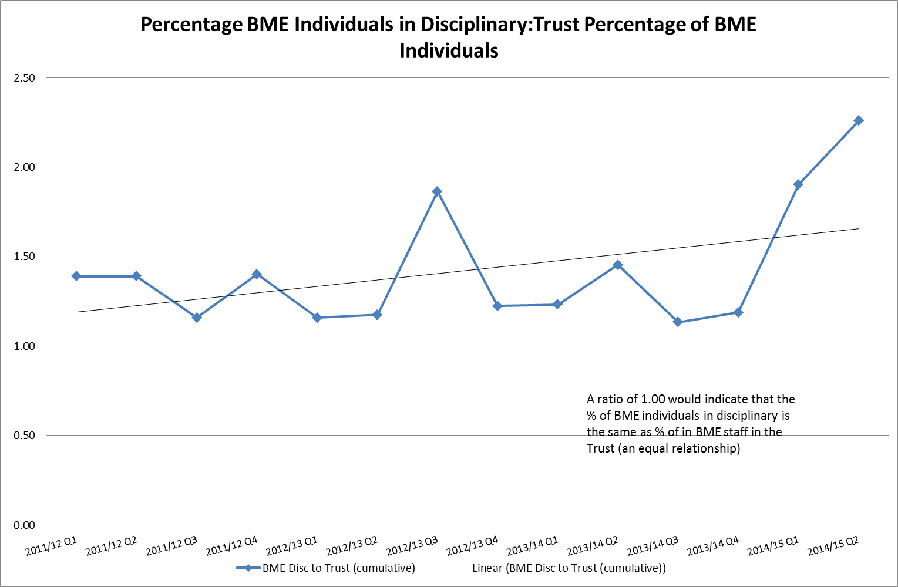

The Trust is aware of the continued imbalance in the number of BME involved in employee relations issues relative to their overall proportion in the workforce**. It is worth noting that for this data and all the data which follows in this section the numbers of individuals concerned are very small**. We have benchmarked ourselves against another London-based NHS Trust and have found that we are not unique in this respect; indeed this picture is widespread within both the public and private sectors. Never- the- less the Staff Equality and Diversity group have taken (or plan to take) action to address this. These actions include:

* Continued scrutiny of this issue with reports sent to the Clinical Governance Committee chaired by the Non-Executive Director with specific responsibility for E&D issues.
* The Trust continues to send samples of its disciplinary documentation to external solicitors for independent assessment, and this continues to show no evidence of discrimination within the Trust’s disciplinary policies or processes.
* Working to ensure that equality and diversity issues continue to be mainstreamed into our management and leadership development programs.
* Continuing to roll out cultural competency awareness sessions within our leadership development programmes.
* Continuing to review our key staffing policies to ensure that they are accessible to all staff through the use of frequently asked questions.

**Graph 2: Gender**

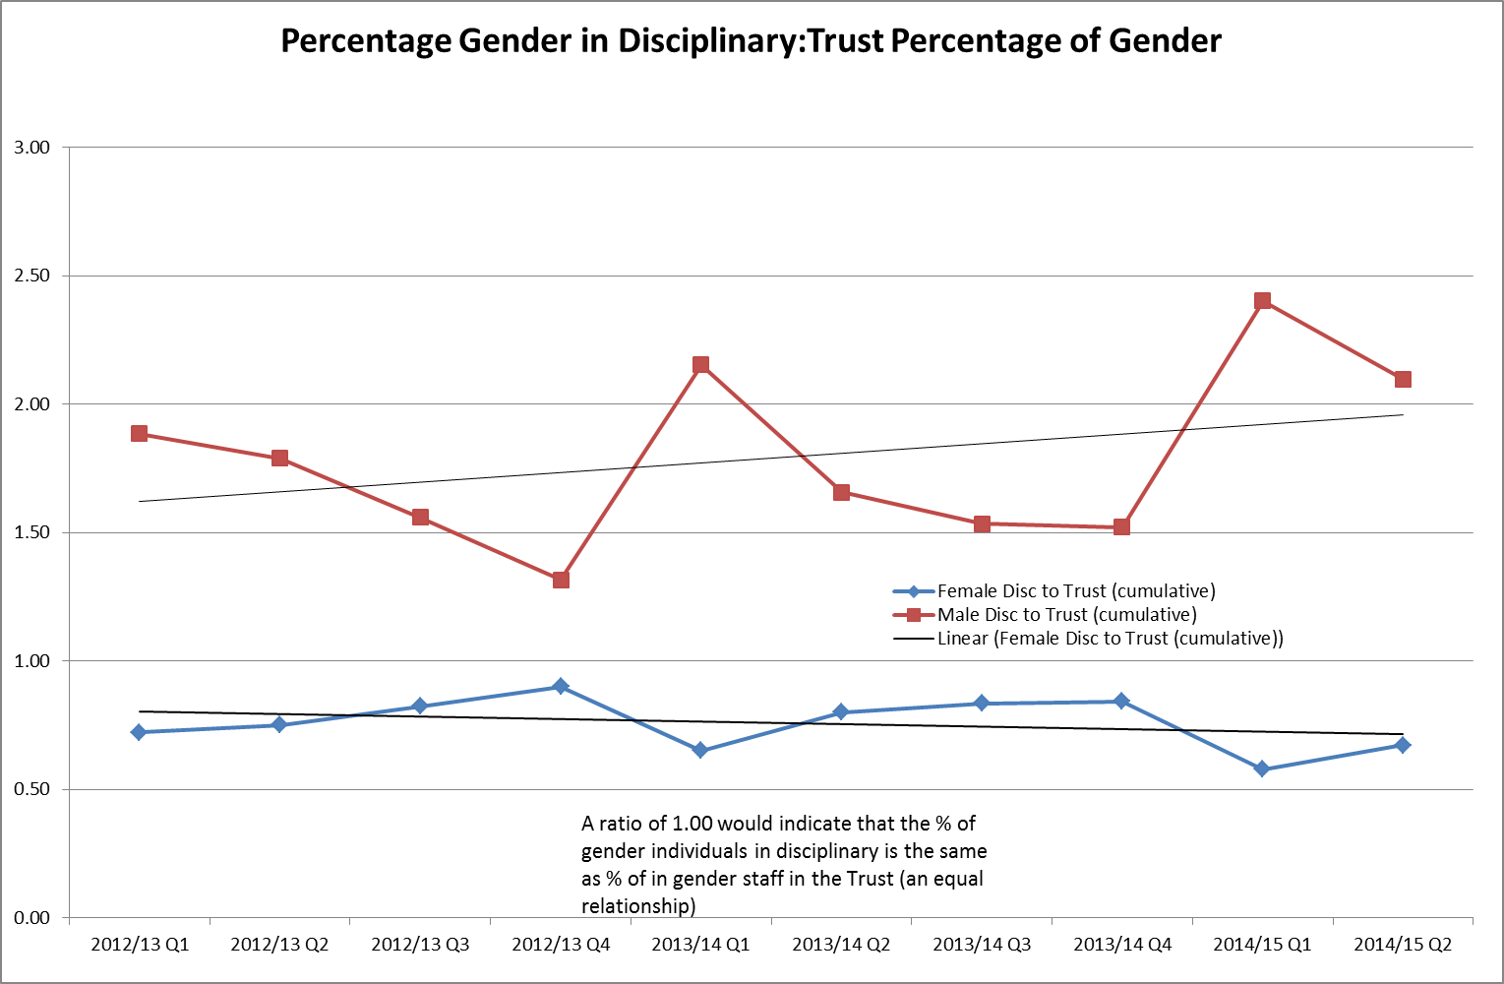

**Graph 3: Age**

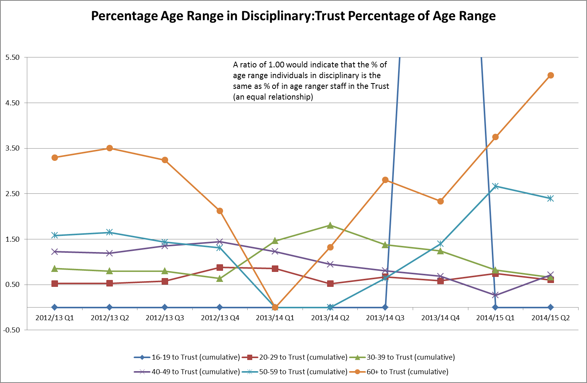

**Graph 4: Disability**

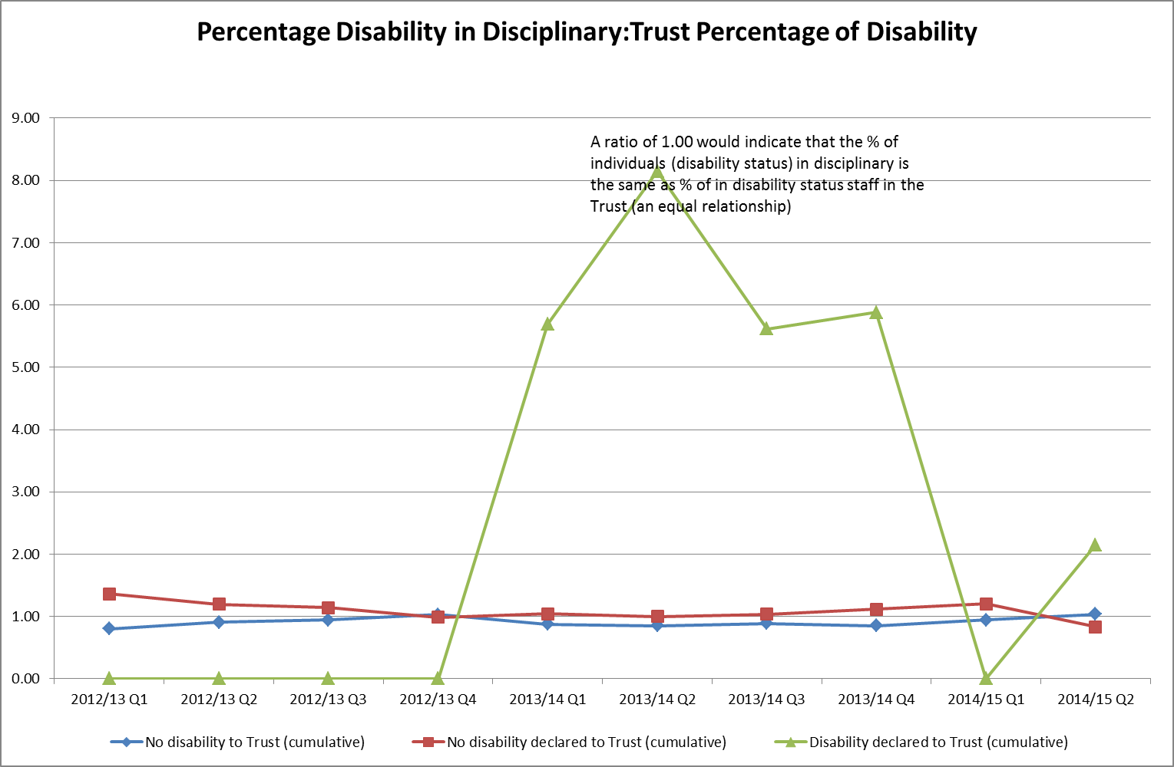

**Graph 5: Sexual Orientation**

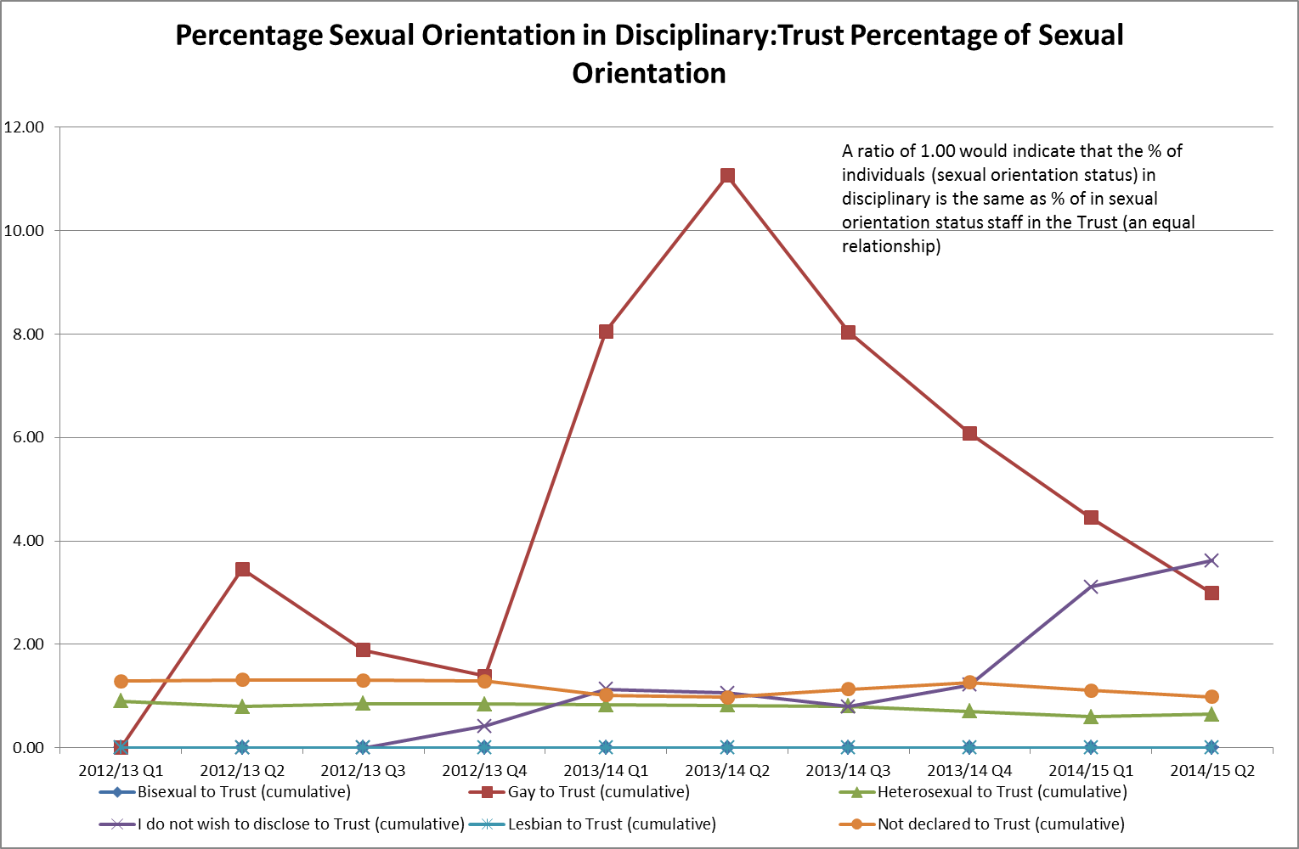

**Graph 6: Maritial Status**

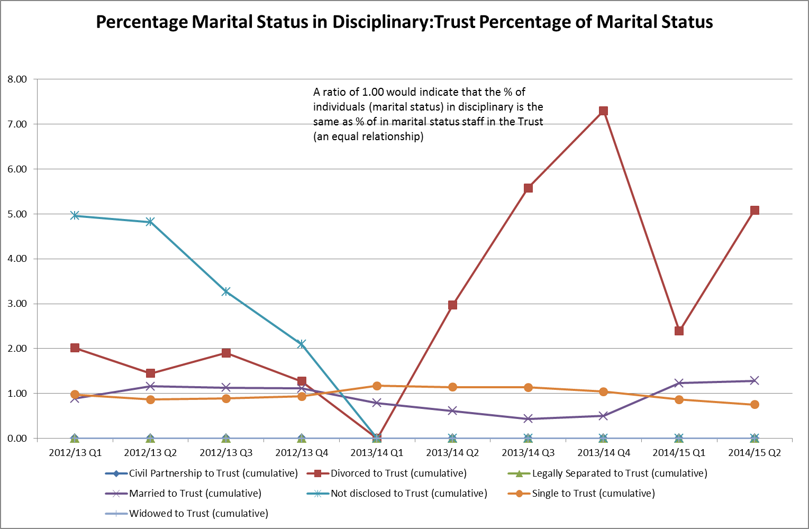

**Graph 7: Religious Belief**

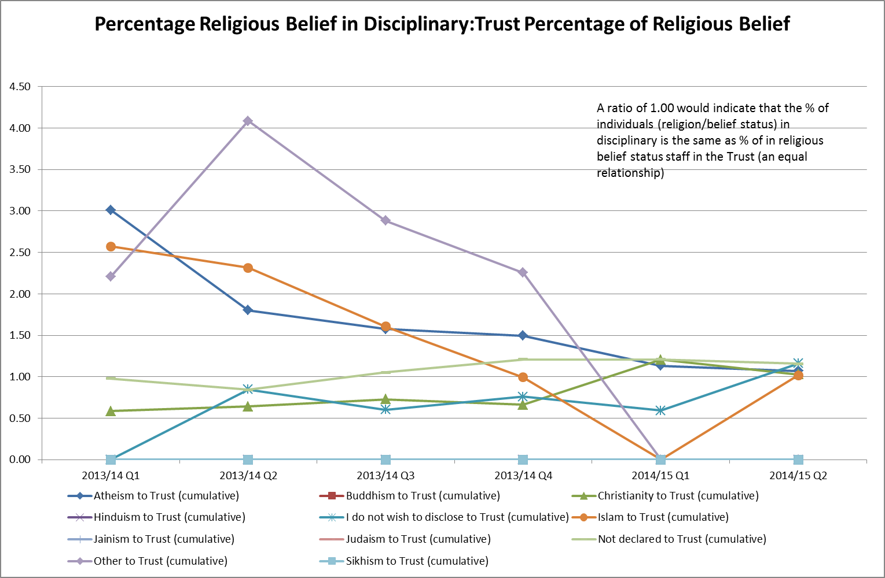

Table 30 – Number of grievances

|  |  |  |
| --- | --- | --- |
|  | Nov 2013-2014 | Nov 2012 – Nov 2013 |
| Number of Grievances | 2 | 4 |
| GENDER |  |  |
| Male | 1 (50%) | 1 (25%) |
| Female | 1 (50%) | 3 (75%) |
| Not known | 0 | 0 |
| ETHNICITY |  |  |
| White | 0 | 2 (50%) |
| BME | 2 (100%) | 2 (50%) |
| Not known |  | 0 |
| DISABILITY |  |  |
| Non-disabled | 1 (50%) | 3 (75%) |
| Disabled | 0 | 0 |
| Not known | 1 (50%) | 1 (25%) |
| AGE RANGE |  |  |
| 16 – 29 | 0 | 0 |
| 30 – 49 | 2 (100%) | 3 (75%) |
| 50 – 59 | 0 | 1 (25%) |
| 60+ | 0 | 0 |
| Not given | 0 | 0 |

Table 31 – Number of redundancies

|  |  |  |
| --- | --- | --- |
|  | Nov 2013-2014 | Nov 2012 – Nov 2013 |
| Number of Redundancies | 4 | 10 |
| GENDER |  |  |
| Male | 0 | 3 (30%) |
| Female | 4 (100%) | 7 (70%) |
| Not known | 0 | 0 |
| ETHNICITY |  |  |
| White | 3 (75%) | 4 (40%) |
| BME | 1 (25%) | 6 (60%) |
| Not known | 0 | 0 |
| DISABILITY |  |  |
| Non-disabled | 3 (75%) | 7 (70%) |
| Disabled | 0 | 1 (10%) |
| Not known | 1 (25%) | 2 (20%) |
| AGE RANGE |  |  |
| 16 – 29 | 0 | 0 |
| 30 – 49 | 1 (25%) | 7 (70%) |
| 50 – 59 | 3 (75%) | 3 (30%) |
| 60+ | 0 | 0 |

Table 32– Number of staff going through mediation

|  |  |  |
| --- | --- | --- |
|  | Nov 2013-2014 | Nov 2012 – Nov 2013 |
| Total mediations | 2 | 4 |
| GENDER |  |  |
| Male | 1 (50%) | 0 |
| Female | 1 (50%) | 4 (100%) |
| Not known | 0 | 0 |
| ETHNICITY |  |  |
| White | 1 (50%) | 4 (100%) |
| BME | 1 (50%) | 0 |
| Not known | 0 | 0 |
| DISABILITY |  |  |
| Non-disabled | 1 (50%) | 1 (25%) |
| Disabled | 0 | 0 |
| Not known | 1 (50%) | 3 (75%) |
| AGE RANGE |  |  |
| 16 – 29 | 0 | 0 |
| 30 – 49 | 2 (100%) | 3 (75%) |
| 50 – 59 | 0 | 1 (25%) |
| 60+ | 0 | 0 |

**Harassment & bullying**

During 2014 there have been two cases of formal harassment & bullying. In addition there were 5 cases of harassment and bullying which were resolved informally. We do not disclose details concerning any of these due to the extremely sensitive nature of the cases and need to protect the anonymity of staff when the number of cases is so low.

# Conclusion

The Trust aims to openly publish a report on the experience of its staff in this equality data. This data will help to measure the progress made against the equality objectives set by the Trust and help to guide on the new objectives that need to be agreed this year for the next three years. The data will also be used to inform our Equality Assessment scheme, under which we assess all policies and consultations relating to staff to check for any potential detriments along the grounds of all the protected characteristics.

The Trust’s Staff Equality and Diversity Group will continue to scrutinise this data and promote actions intended to ensure that the Trust is experienced by a fair and equitable employer by all our staff.